School Name
Mathematics Test 2017
Year 9 |  | Enlargement and Similarity | Non Calculator
Skills and Knowledge Assessed:  - Use the enlargement transformation to explain similarity and develop the conditions for triangles to be similar (ACMMG220)  - Solve problems using ratio and scale factors in similar figures (ACMMG221) |  |  | Name_________________
Section 1 Short Answer Section
Write all working and answers in the spaces provided on this test paper.

Rectangle M is enlarged to produce Rectangle N.
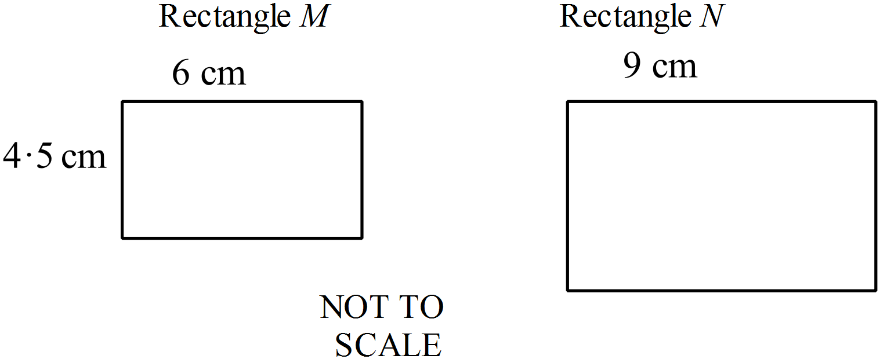

What is the enlargement factor?

…………………………………………..

…………………………………………..

…………………………………………..
A triangle has sides 6 cm, 8 cm and 10 cm and a right angle between the two shorter sides.
An enlargement of this triangle is drawn, with an enlargement factor of 3.
Describe the sides and angles of the new shape.

……………………………………………………………………………………………....

……………………………………………………………………………………………….

A rectangle K is enlarged with scale factor 3, to produce rectangle L.
What are the measurements marked a and b?
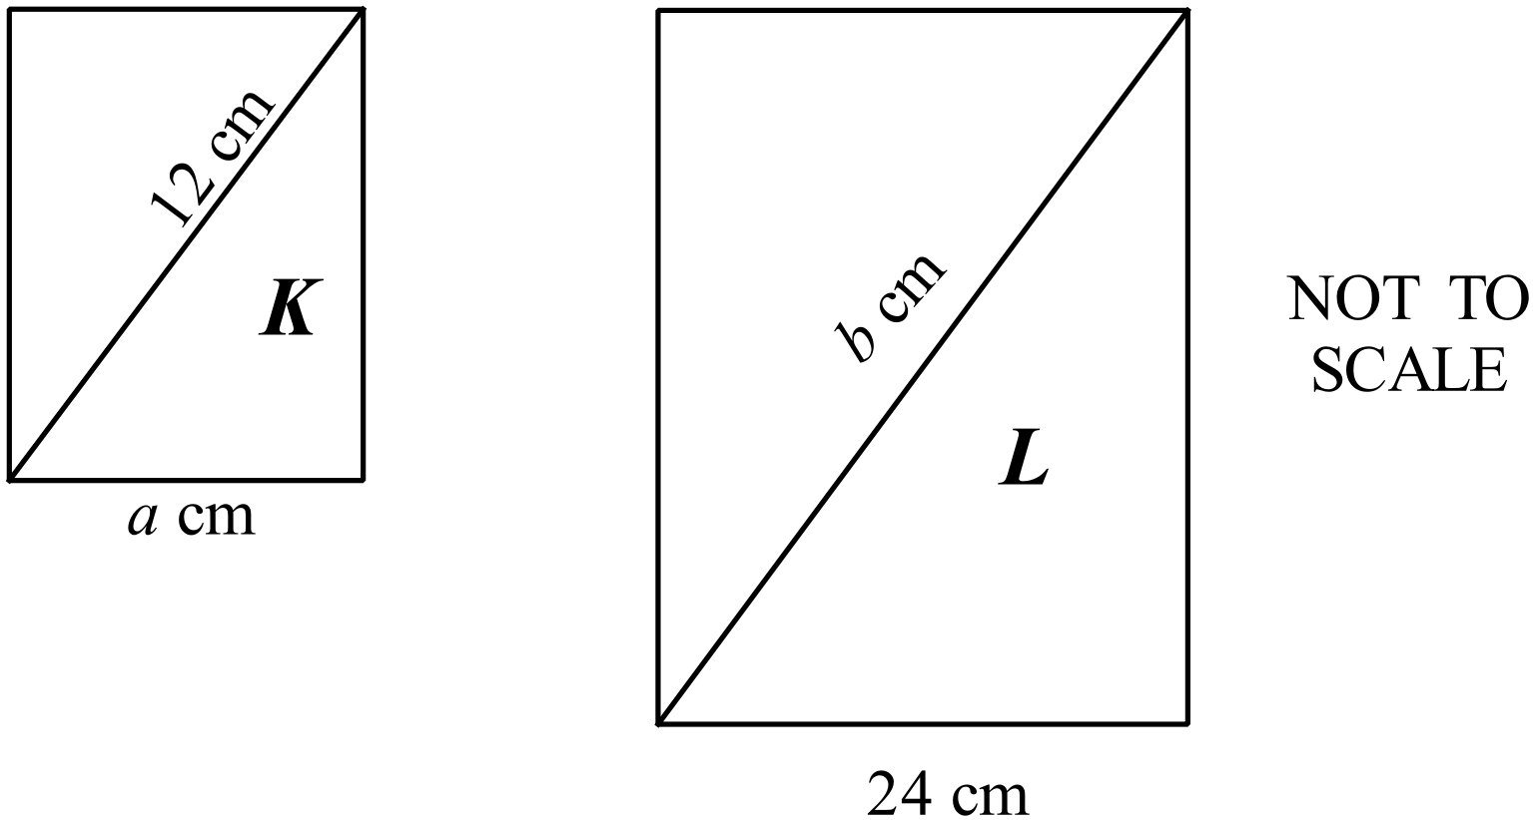

……………………………………………………………………………………………....

……………………………………………………………………………………………....

……………………………………………………………………………………………….

 is enlarged to give 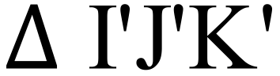
There are equal divisions along the construction lines which were used to draw the enlargement.
Find the scale factor for the enlargement.
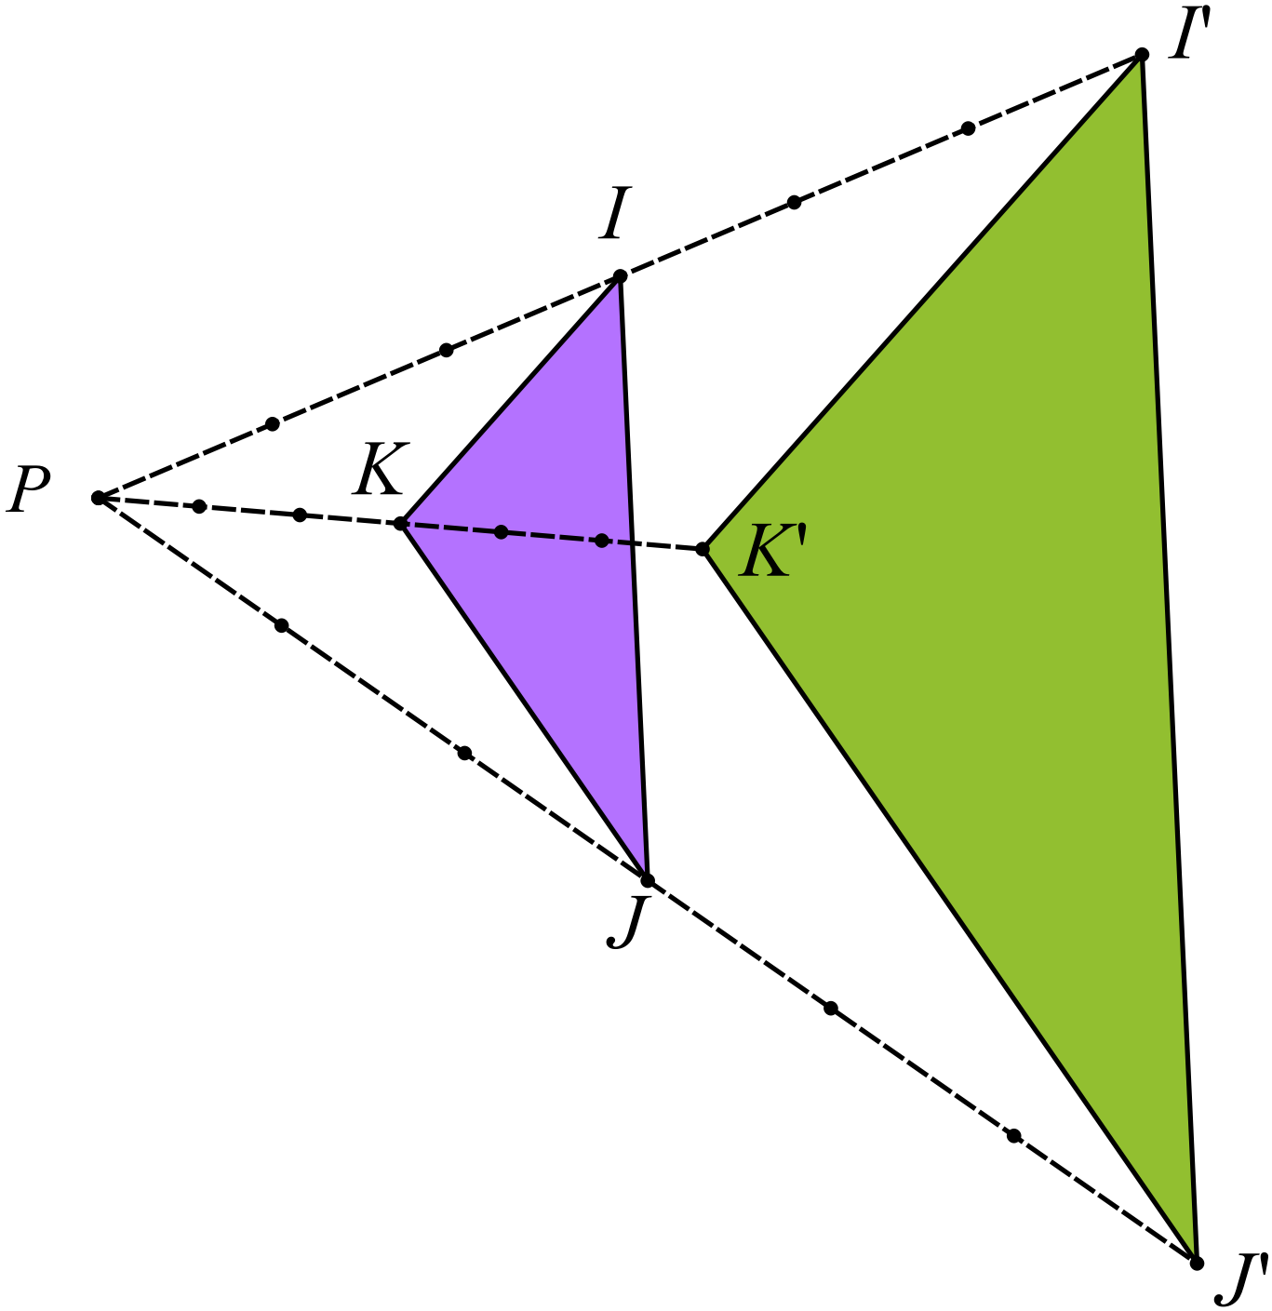

..................................................................

..................................................................

..................................................................

..................................................................

The quadrilateral KLMN is enlarged to an image K’L’M’N’.
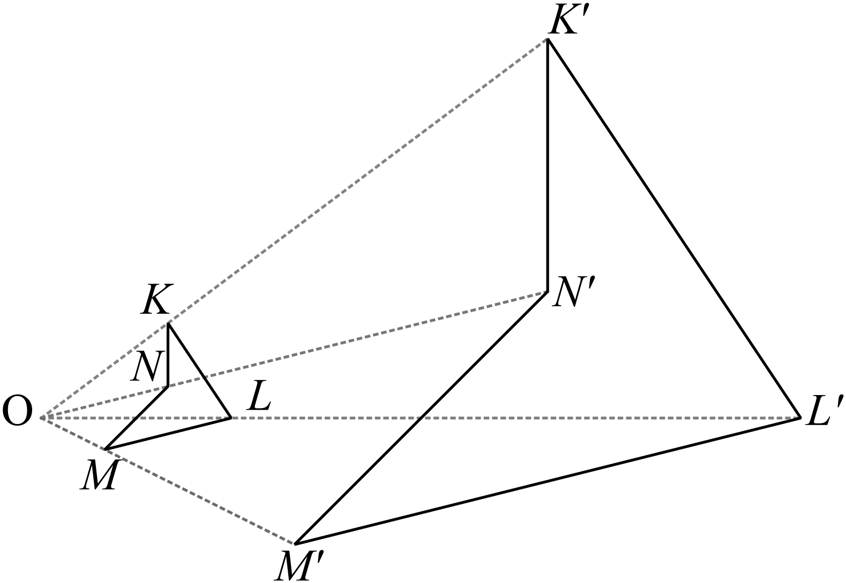By measuring and calculation find the scale factor of the enlargement.

………………………………………………

………………………………………………

………………………………………………

……………………………………………….
The two rectangles shown are similar. The scale factor is 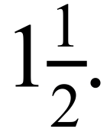
What is the length of AB?

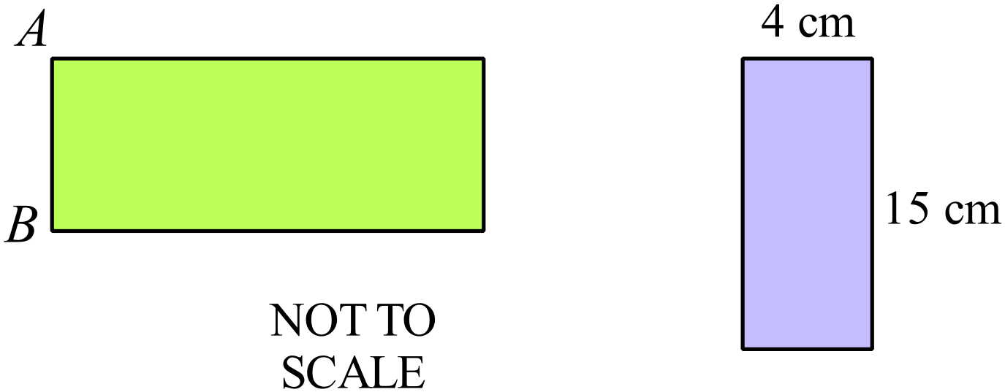
NOT TO
SCALE

…………………………………………..…………………………………………..

…………………………………………..…………………………………………..

…………………………………………..…………………………………………..
The triangle DEF is reduced to an image D’E’F.
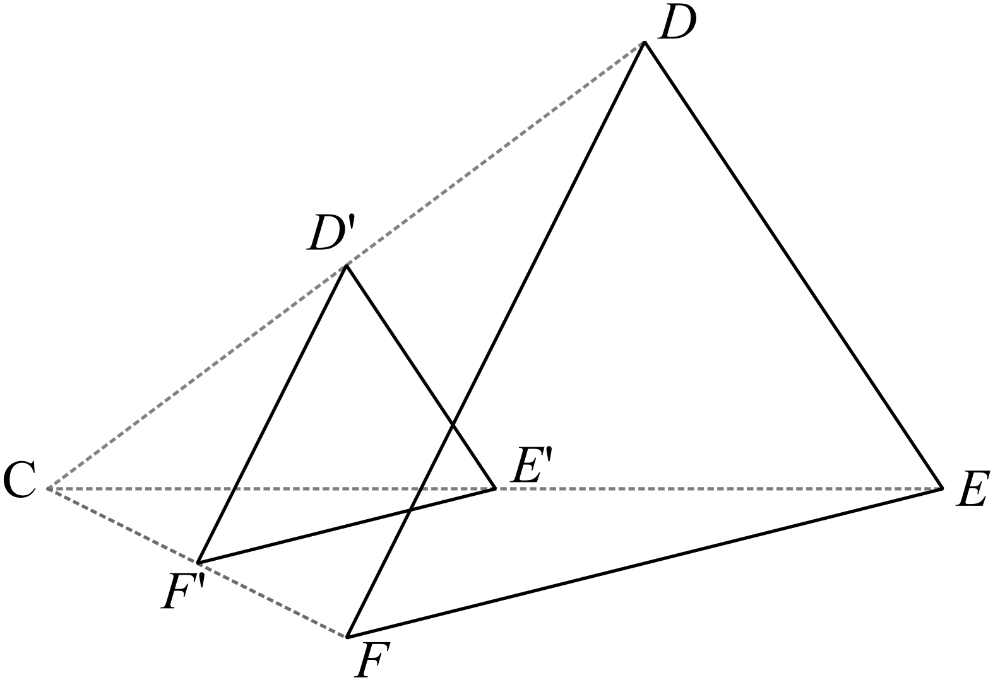By measuring and calculation find the scale factor of the reduction.

………………………………………………

………………………………………………

………………………………………………

……………………………………………….
An isosceles triangle PQR has two sides of 5 cm and one of 7 cm.
Give the dimensions of another triangle which would be similar to 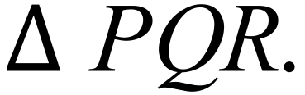 .

……………………………………………………………………………………………....

……………………………………………………………………………………………....

……………………………………………………………………………………………….
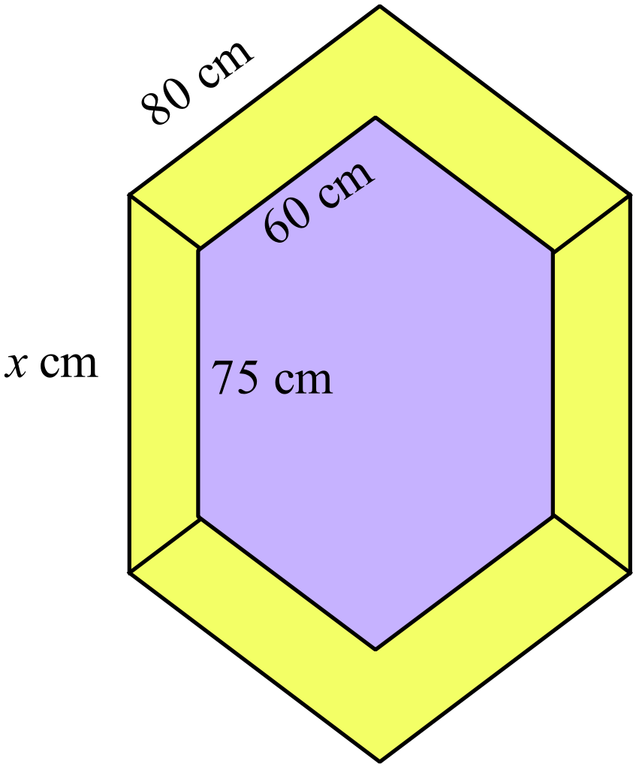A decorative shield is in the shape of two similar irregular hexagons, as shown.

Given the dimensions shown, determine the value of x.

………………………………………………

……………………………………………....

………………………………………………

……………………………………………….
 | 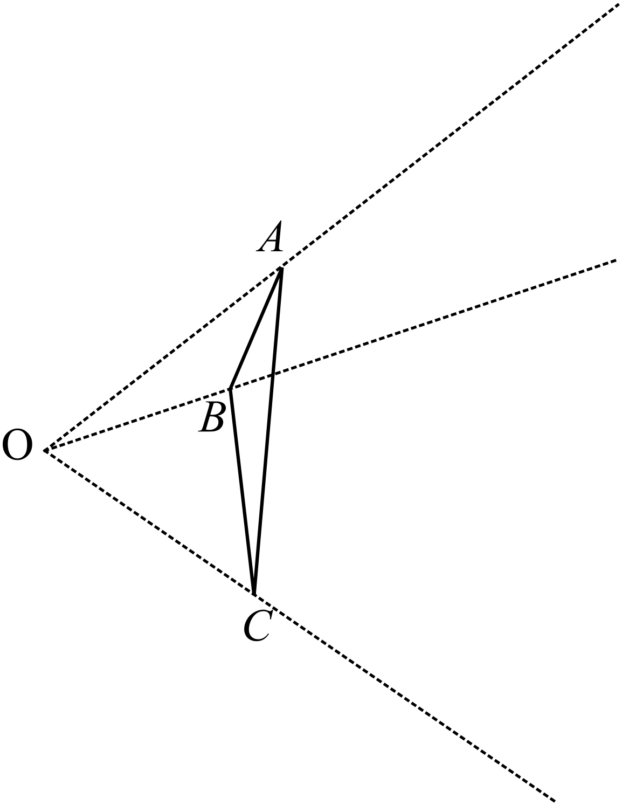By measurement and calculation complete the enlargement of , with centre O and scale factor = 2.
These two parallelograms are similar.
NOT TO
SCALE
Calculate the length of PQ.
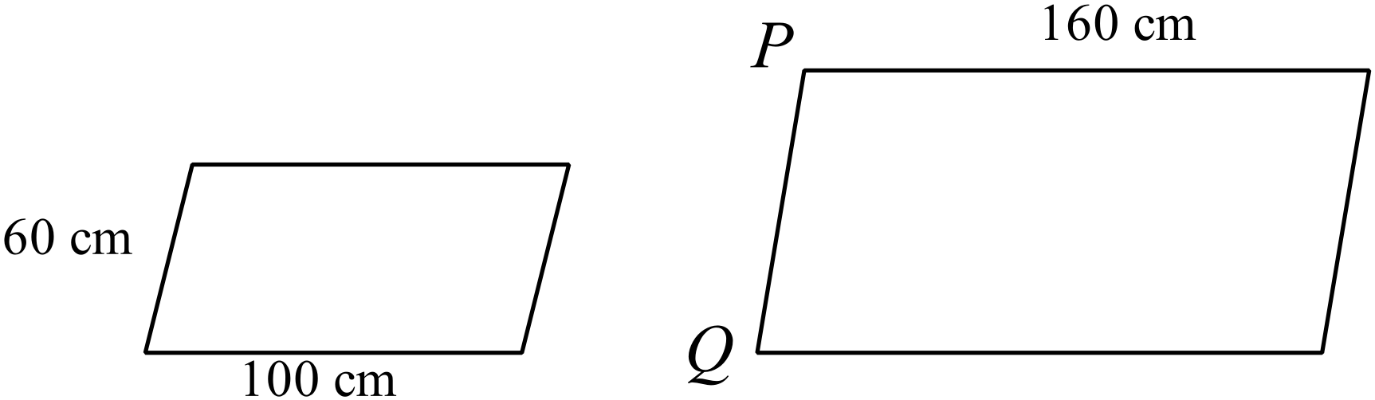

……………………………………………………………………………………………....

……………………………………………………………………………………………….
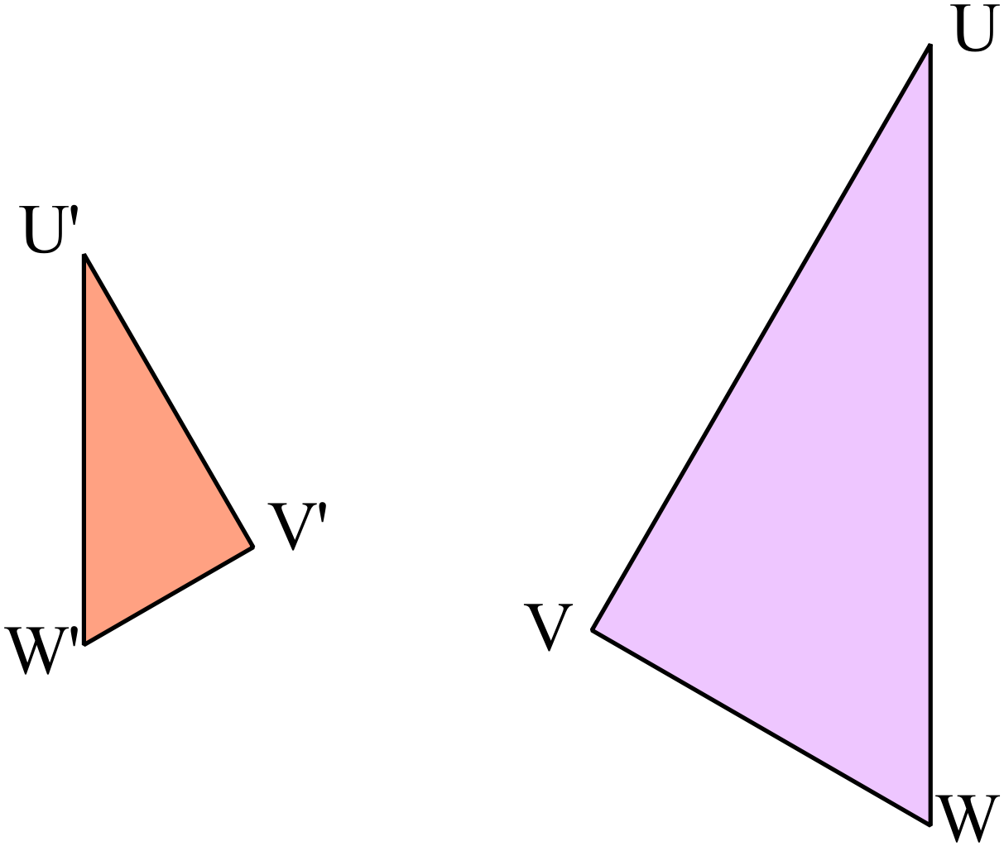By measurement and calculation find the scale factor of the enlargement.

……………………………………………………………………………………………....

……………………………………………………………………………………………....

……………………………………………………………………………………………….
Two similar right triangles are shown.
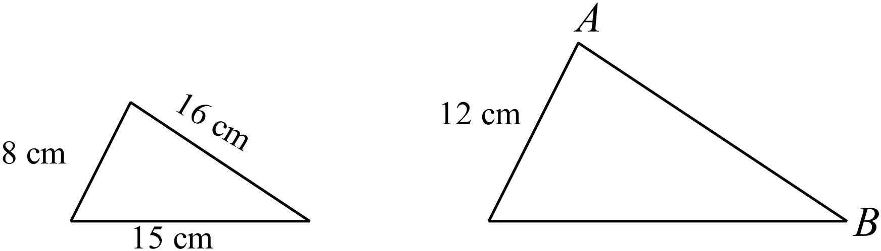What is the length of AB?

NOT TO
SCALE

…………………………………………………………………………………………

……………………………………………....…………………………………………

…………………………………………………………………………………………

……………………………………………….…………………………………………
Explain why 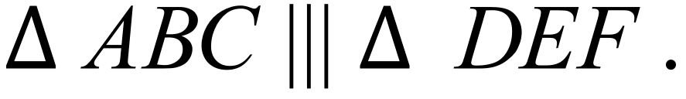
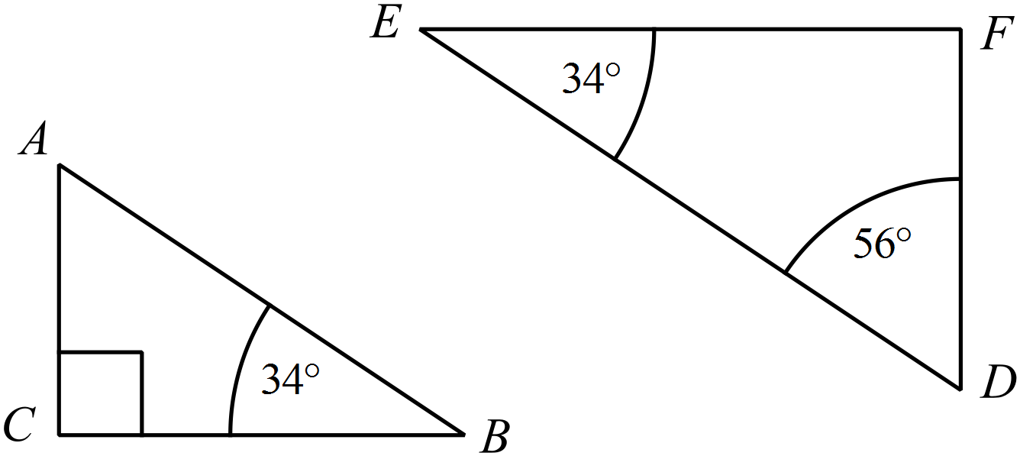

………………………………………………………………………………………..

………………………………………………………………………………………..

………………………………………………………………………………………..
A balcony is supported by two parallel brackets, as shown
The shorter bracket is attached to the wall 12 m below the balcony and the longer one is 6m below this.
Use this information to calculate the length of the longer bracket (GH).
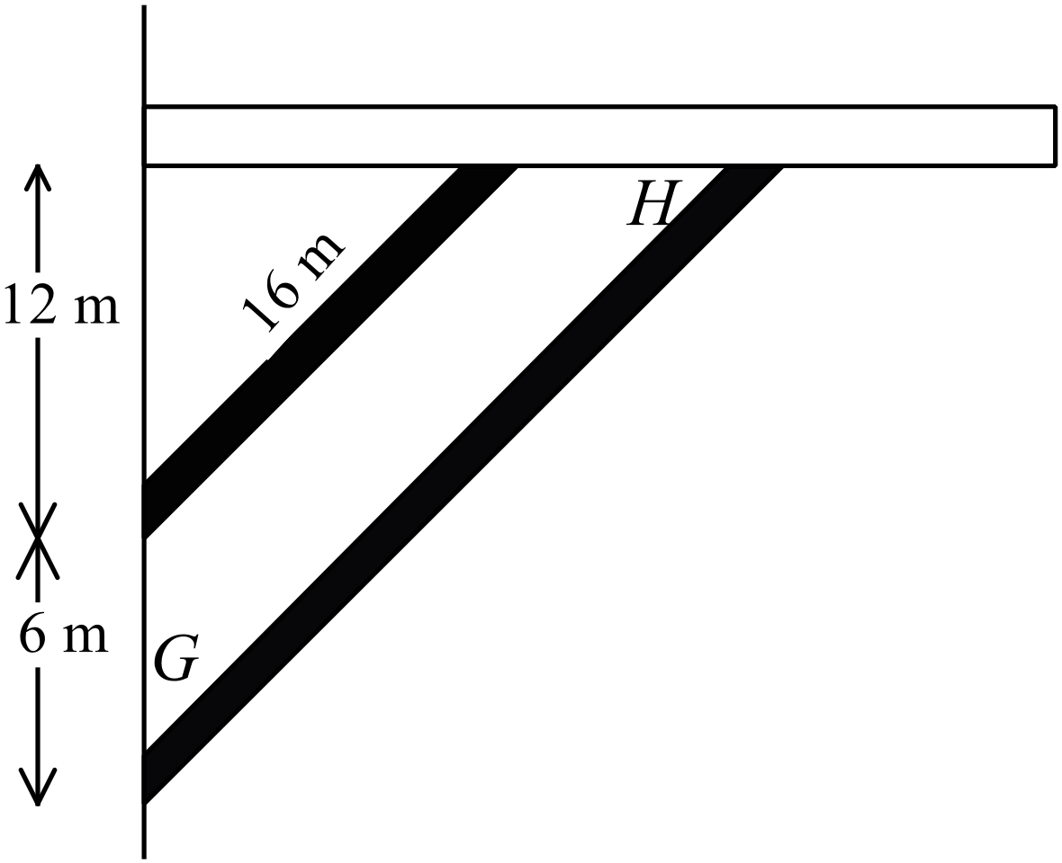
NOT TO
SCALE

……………………………………………………………………………………………....
……………………………………………………………………………………………....
……………………………………………………………………………………………..
A pair of similar triangles are drawn between a pair of parallel line segments, as shown.
Calculate the value of k.
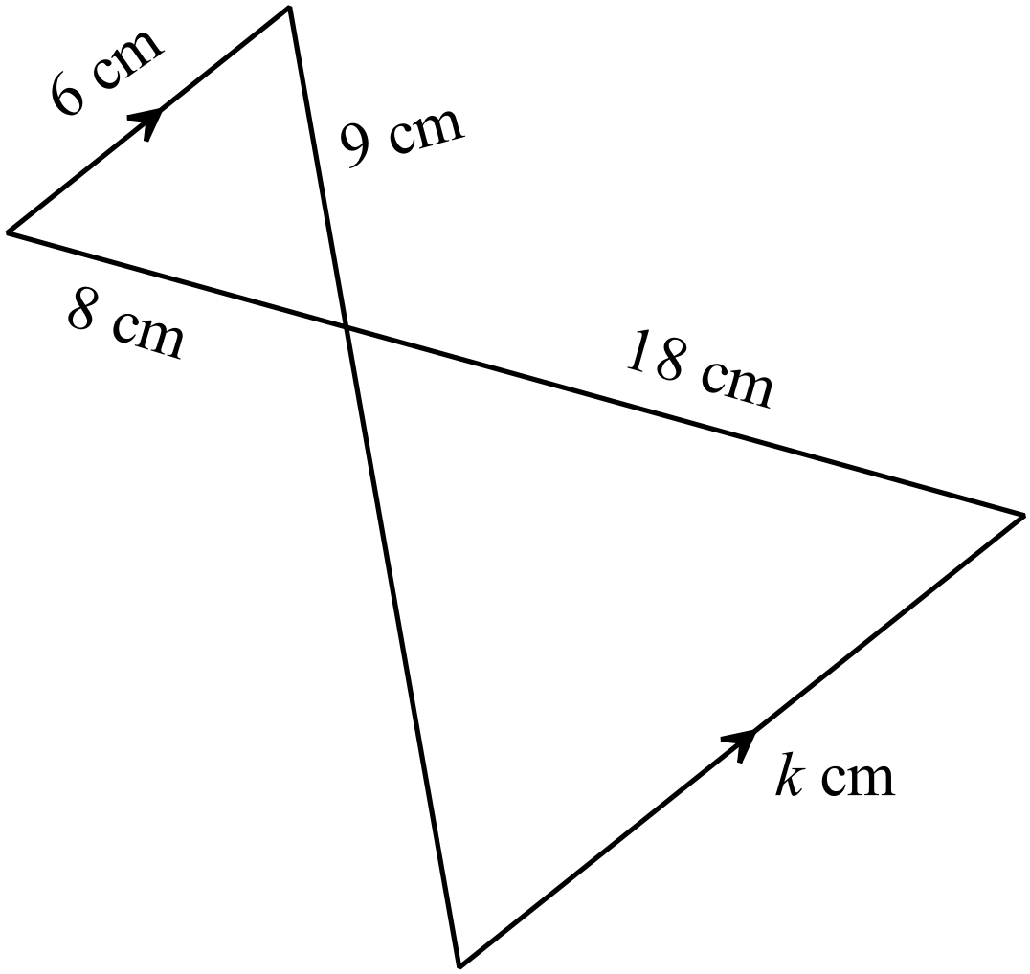

……………………………………………………………………………………………....
……………………………………………………………………………………………....
……………………………………………………………………………………………….

School Name
Mathematics 2017
Year 9 |  | Enlargement and Similarity | Calculator Allowed
 |  | Enlargement and Similarity | Name_________________
Section 2 Multiple Choice Section
Mark all your answers on the accompanying multiple choice answer sheet, not on this test paper. You may do any working out on this test paper. Calculators are allowed for this section.

By measurement and calculation, determine what scale factor would enlarge Rectangle D to Rectangle E?
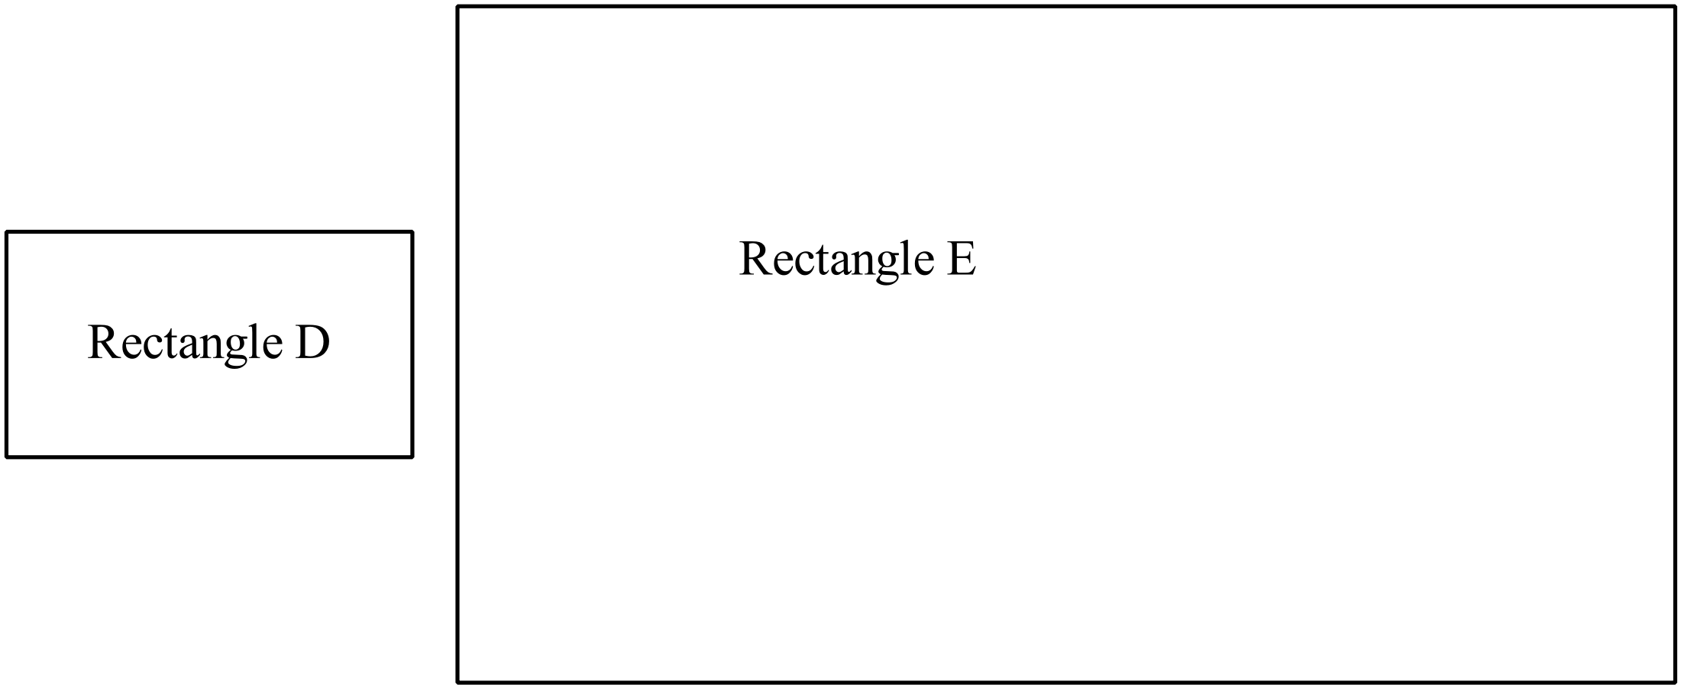

A. 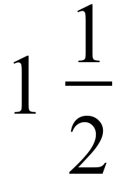 B. 2 C. 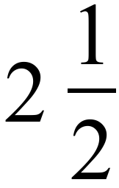 D. 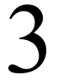
A regular hexagon with sides 16 cm is enlarged with a scale factor of 2.5.
What are the side lengths of the image?

A. 6.4 cm
B. 18.5 cm
C. 24 cm
D. 40 cm
Quadrilateral ABCD is enlarged with a scale factor of 3.
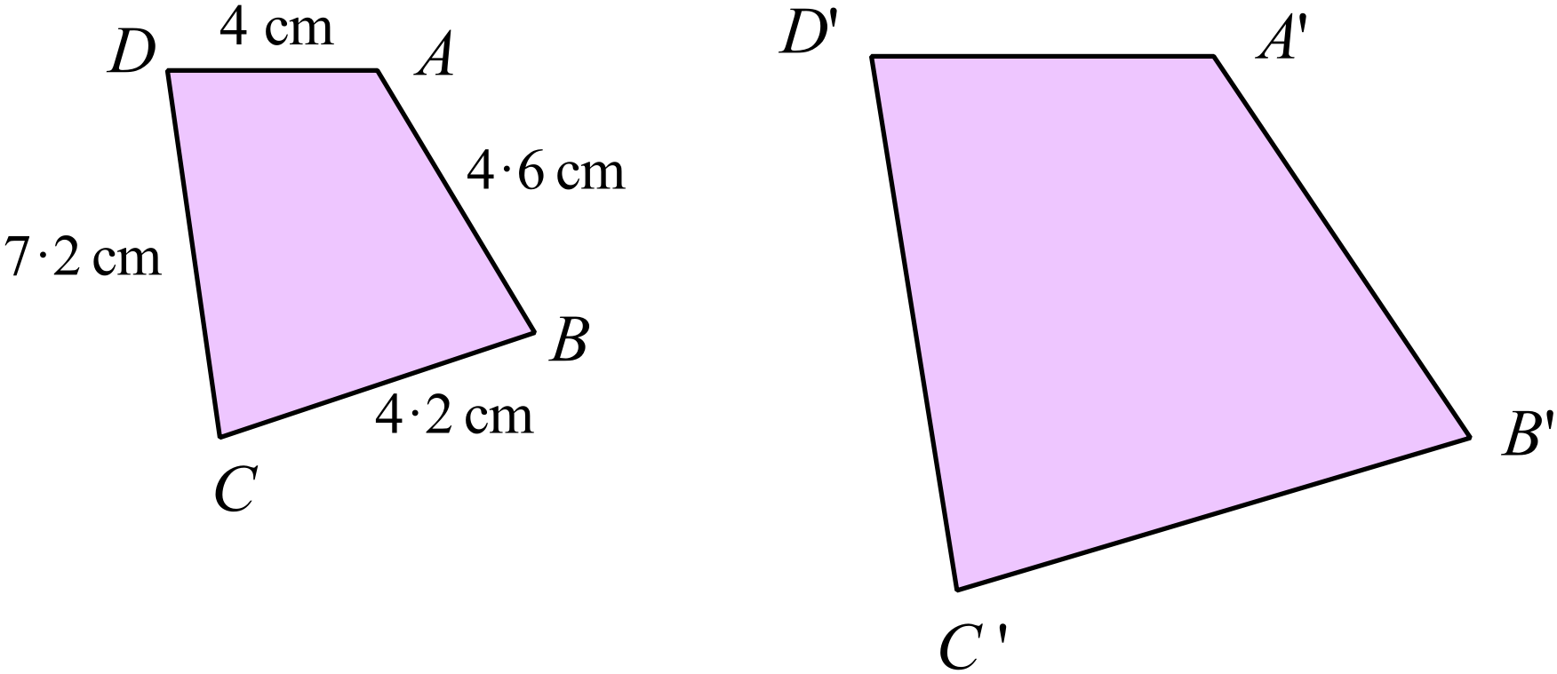Which side in the image would be 12.6 cm in length?

- A’B’ B. B’C’ C. C’D’ D. D’A’
A statue in a park measures 60 cm across its base and stands 240 cm high.
A model is made of the statue which is similar to the original, but measures 12 cm across its base.

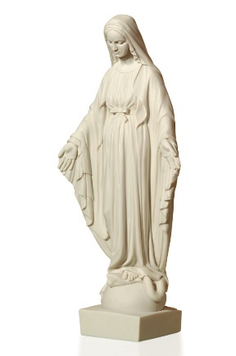
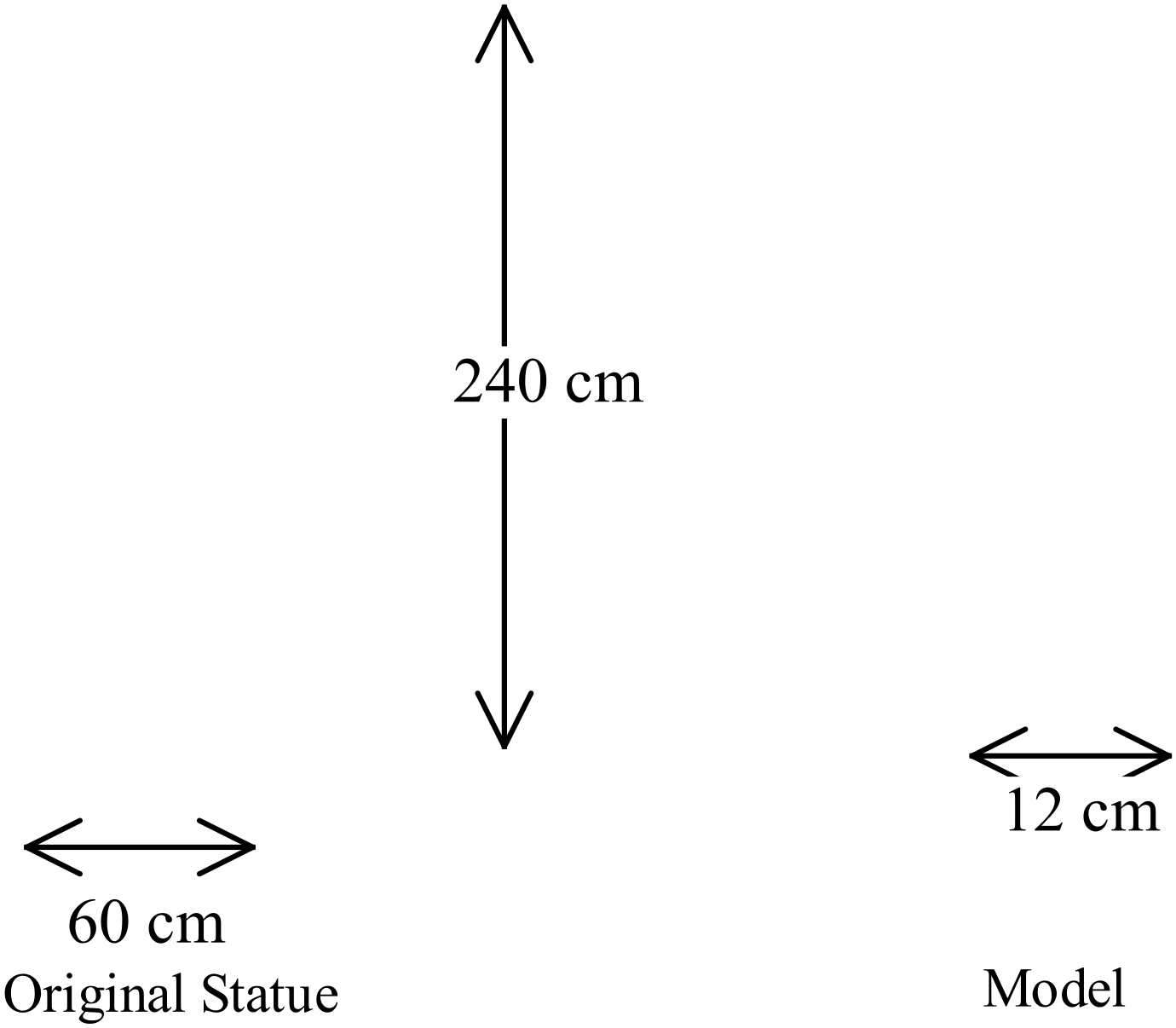

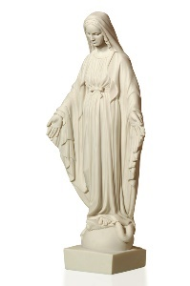
NOT TO
SCALE

What is the height of the model?

A. 48 cm B. 54 cm C. 80 cm D. 720 cm
The two parallelograms below are similar.
NOT TO
SCALE
Which is not true?

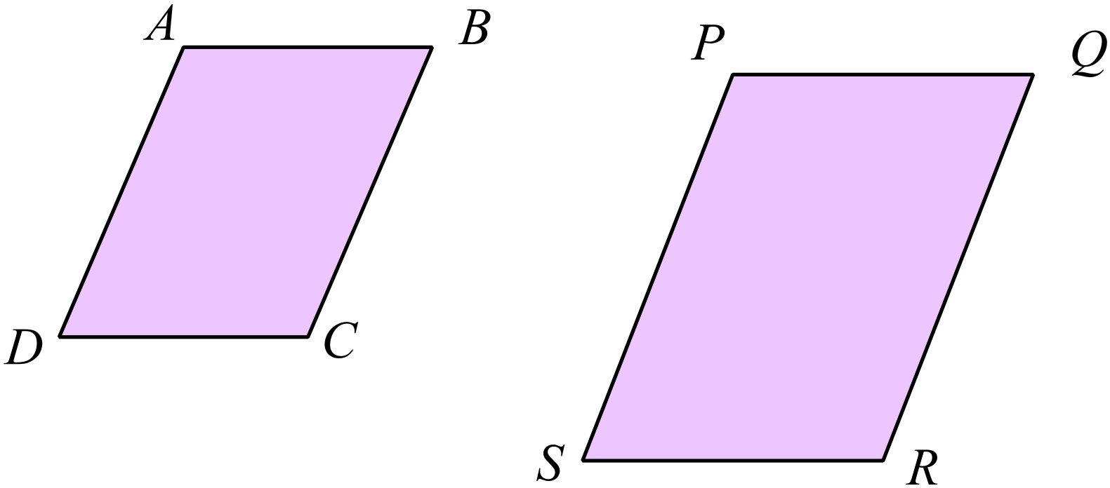
A. 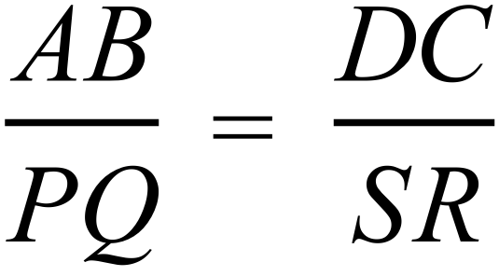
B. 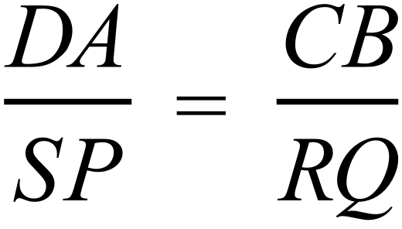
C. 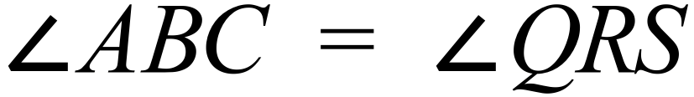
D. 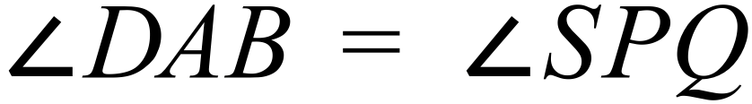

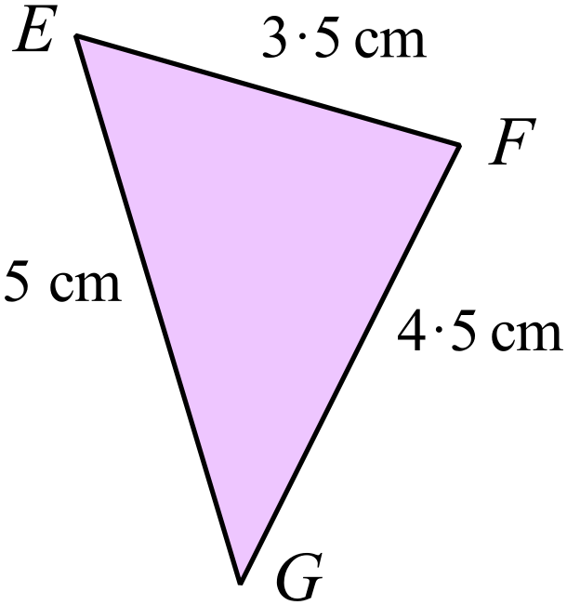Which of the triangles shown below is similar to triangle EFG?

NOT TO
SCALE

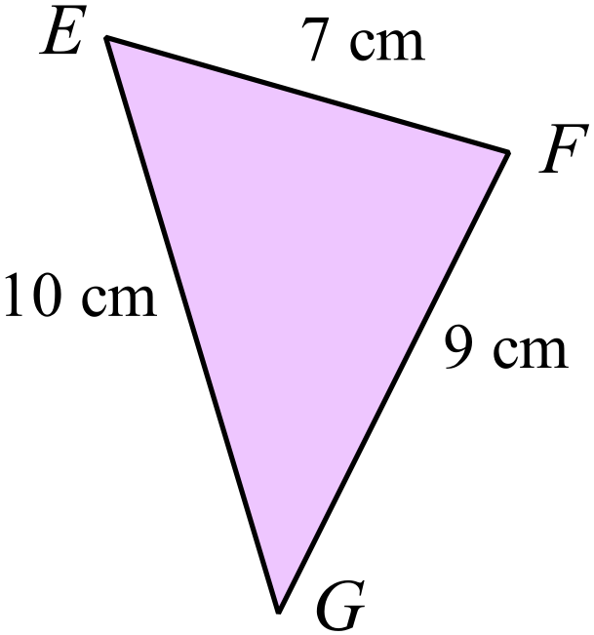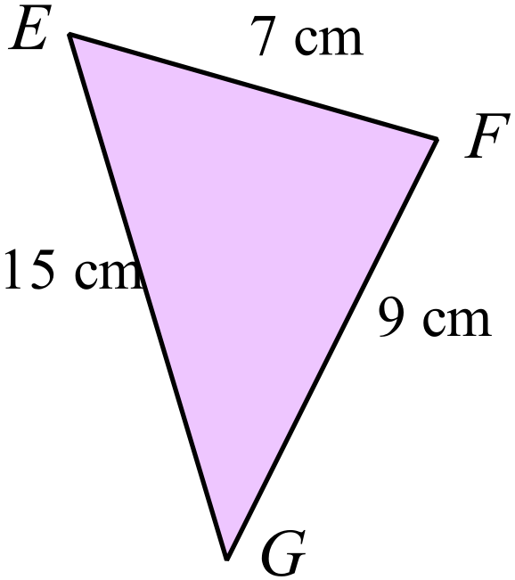
A. B.

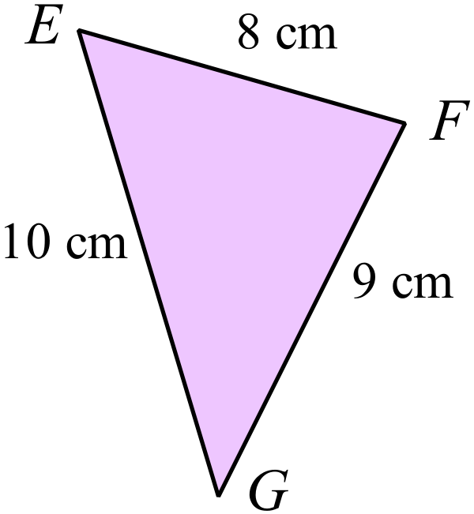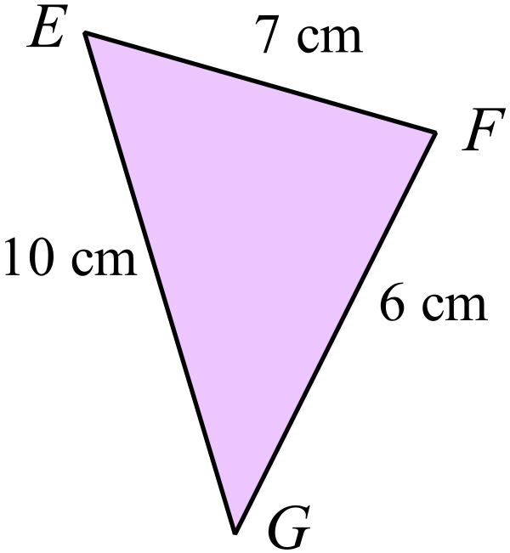

C. D.

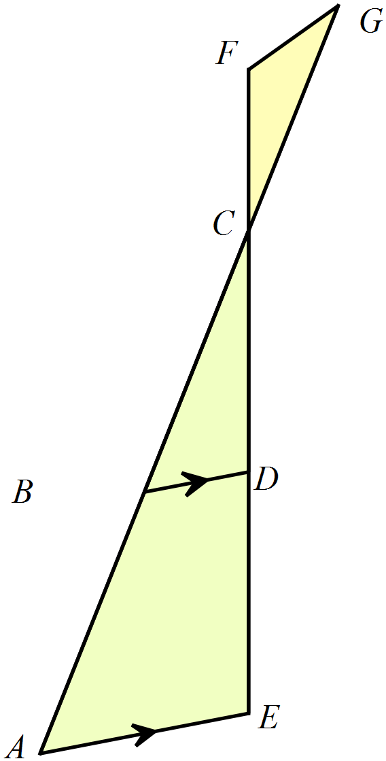Which two triangles are similar in this diagram?
NOT TO
SCALE

A. 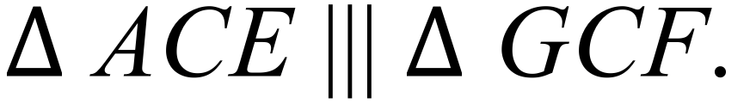
B. 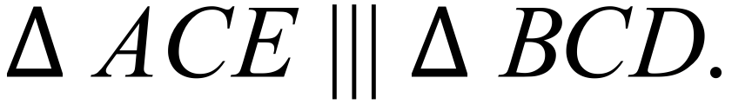
C. 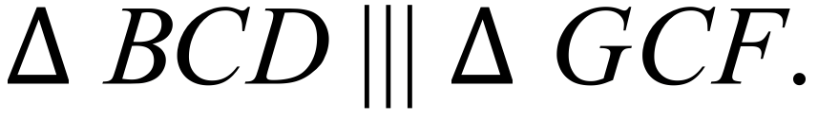
D. 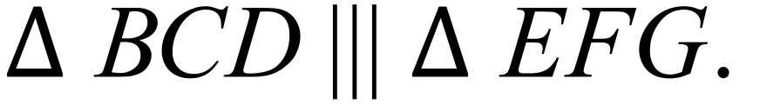

Which statement is not true?
A. Any two squares are similar.
B. Any two equilateral triangles are similar.
C. Any two isosceles triangles are similar.
D. Any two regular octagons are similar.
This elevation of a building is drawn to a scale of 1 : 150.
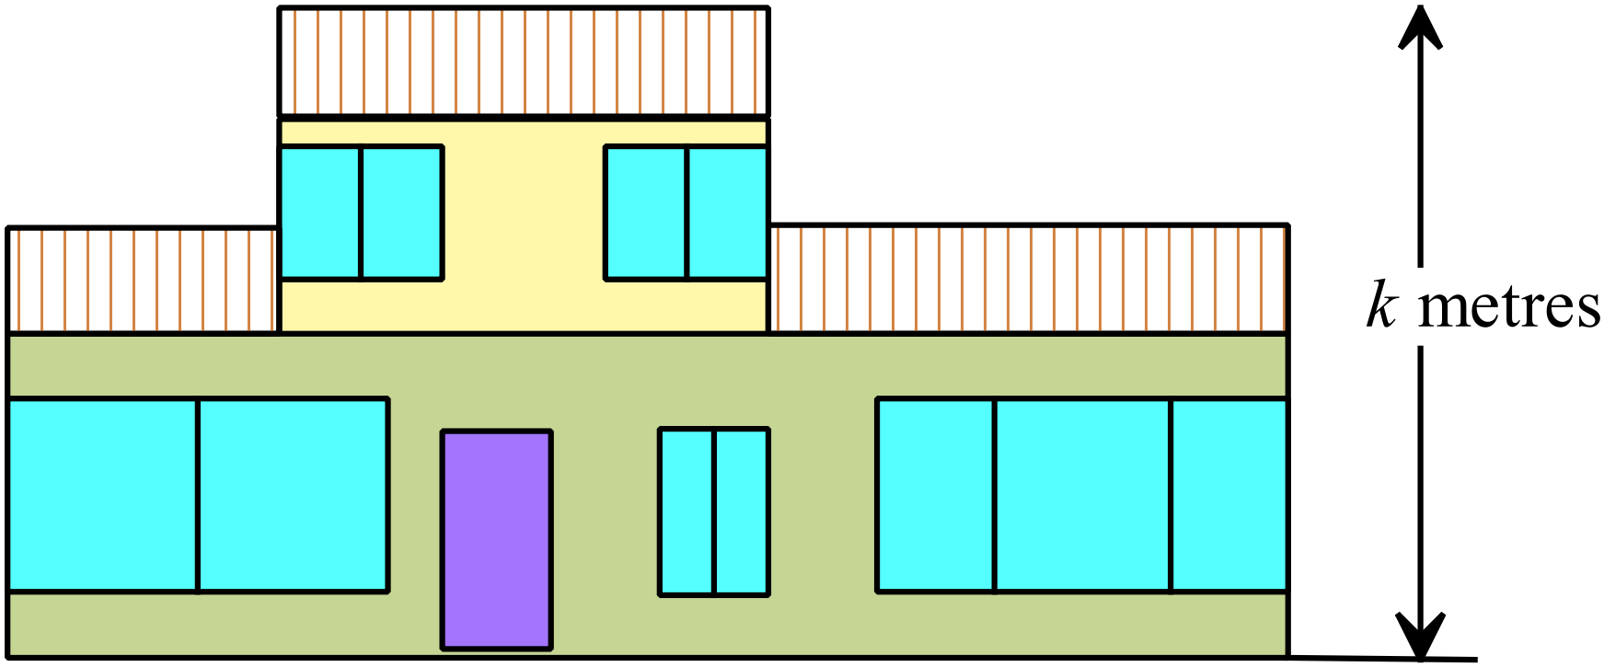

What is the value of k (the height of the actual building)?

A. 6.0 m B. 6.75 m C. 7.5 m D. 9.0 m
A power pole casts a 6.5 m shadow while a nearby post which is 1.5 m tall, casts a 1.2 m shadow.
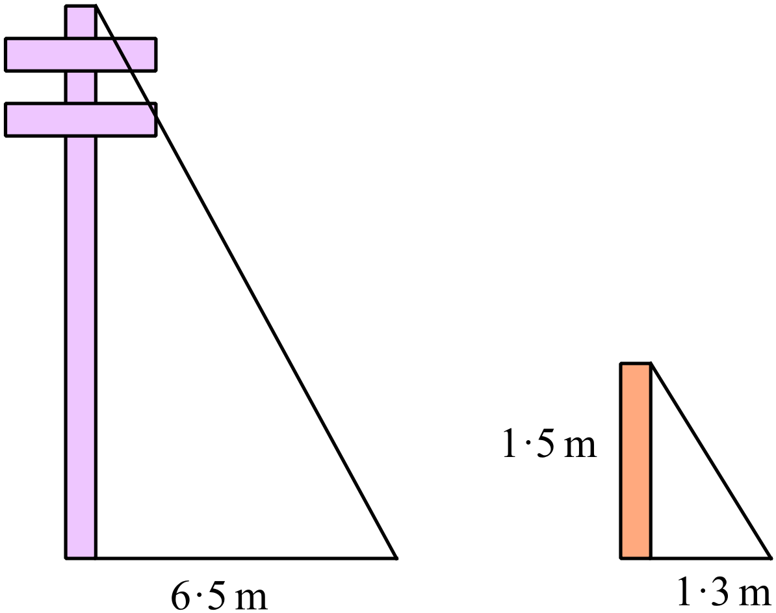

What is the height of the power pole?

A. 5.6 m B. 7.2 m C. 7.5 m D. 8.1 m
Which reason could be used to prove that 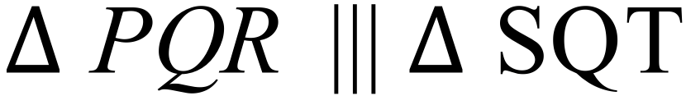 ?
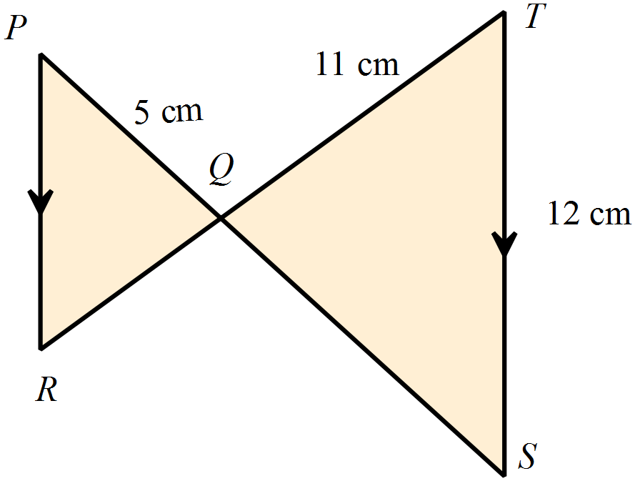

NOT TO
SCALE

A. The three corresponding angles of the triangles are equal.
B. The three corresponding angles of the triangles are in proportion.
C. The three corresponding sides of the triangles are in proportion.
D. Two corresponding sides of the triangles are in proportion and the included angle is equal.
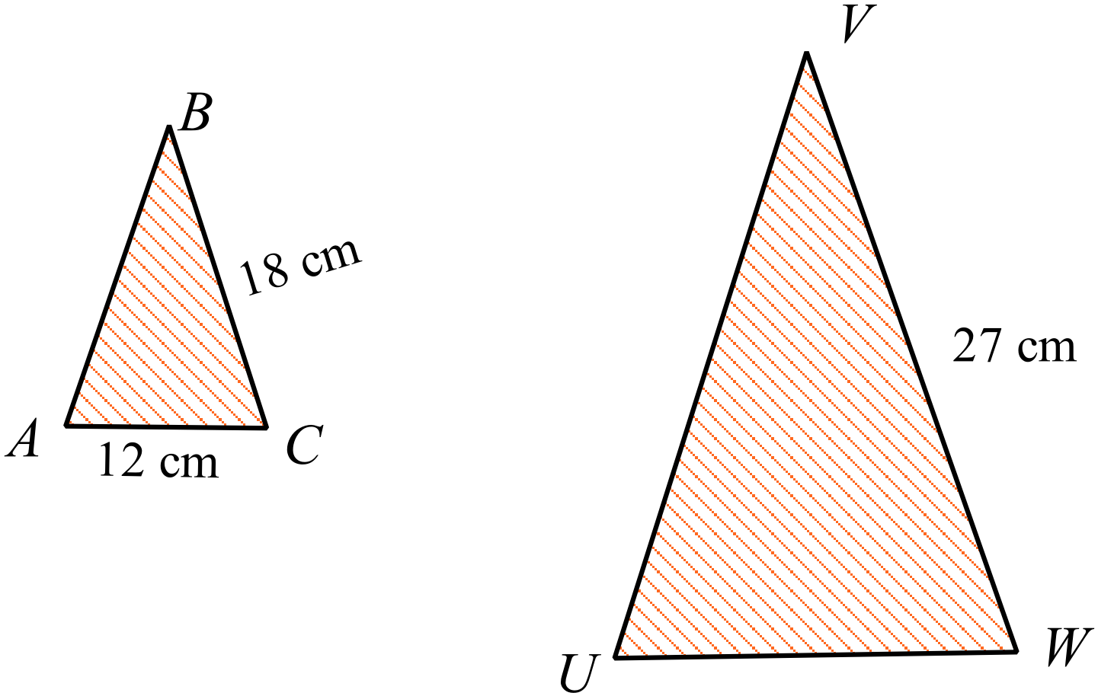  and  are similar.
What is the length of UW’?

A. 7.5 cm
NOT TO
SCALE
B. 18.0 cm
C. 19.2 cm
D. 40.5 cm

Quadrilateral  is an enlargement of .
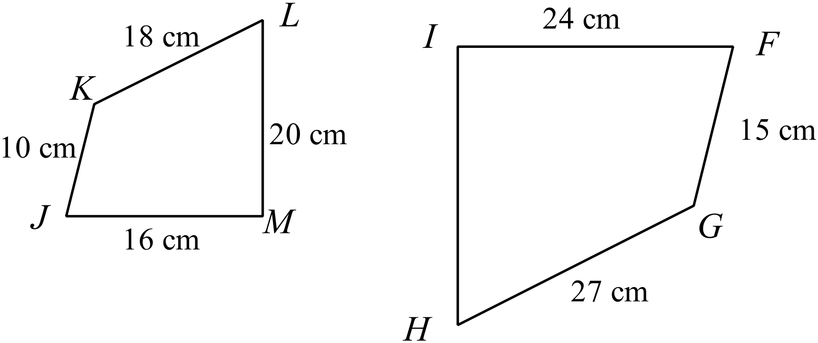

What is the length of HI?

A. 18 cm B. 24 cm C. 27 cm D. 30 cm
In the diagram 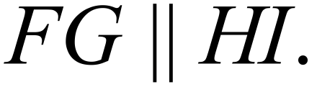
EH = 6 cm, HF = 12 cm and FG = 12 cm.
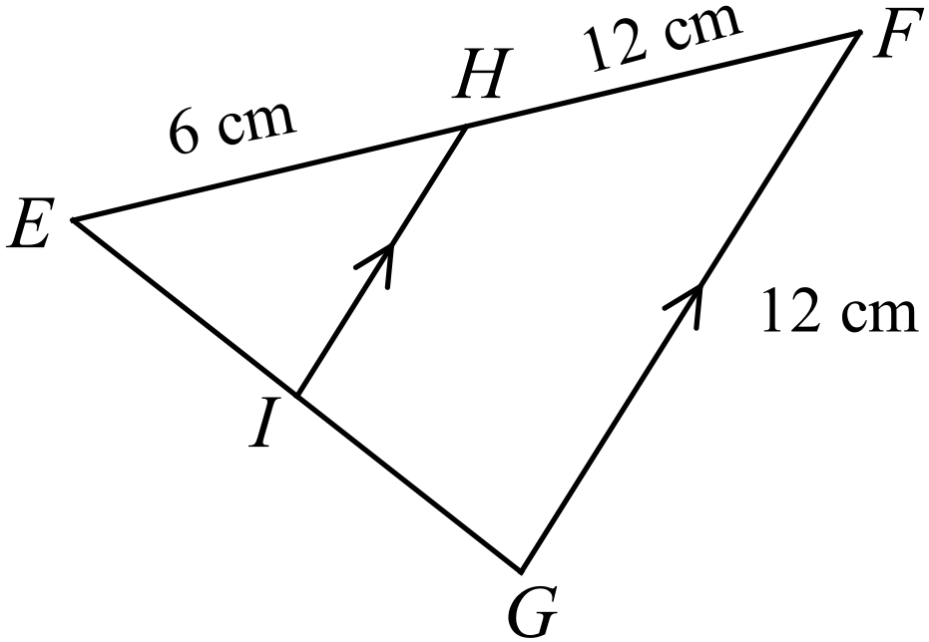What is the length of HI?
NOT TO
SCALE

A. 4.0 cm
B. 4.5 cm
C. 6.0 cm
D. 7.5 cm

What is the value of d?
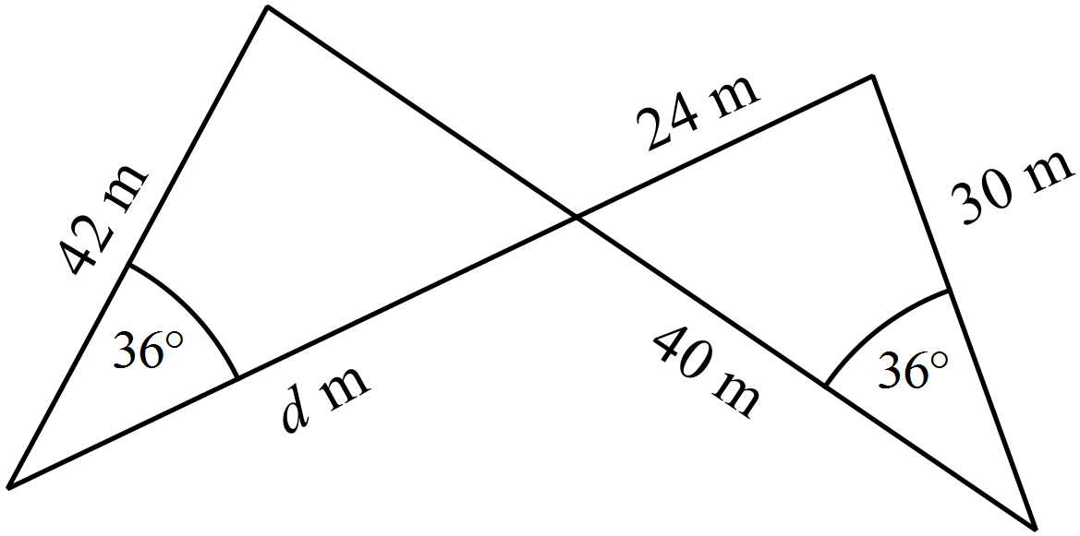

A. 28.6 cm B. 31.5 cm C. 56.0 cm D. 70.0 cm

School Name
Mathematics 2017
Year 9 | Enlargement and Similarity | Calculator Allowed
Year 9 | Enlargement and Similarity | Name___________________
Section 3 Longer Answer Section
Write all working and answers in the spaces provided on this test paper.

 |  | Marks
1. | Use the grid provided to draw an enlargement of quadrilateral ABCD, with a scale factor 2.  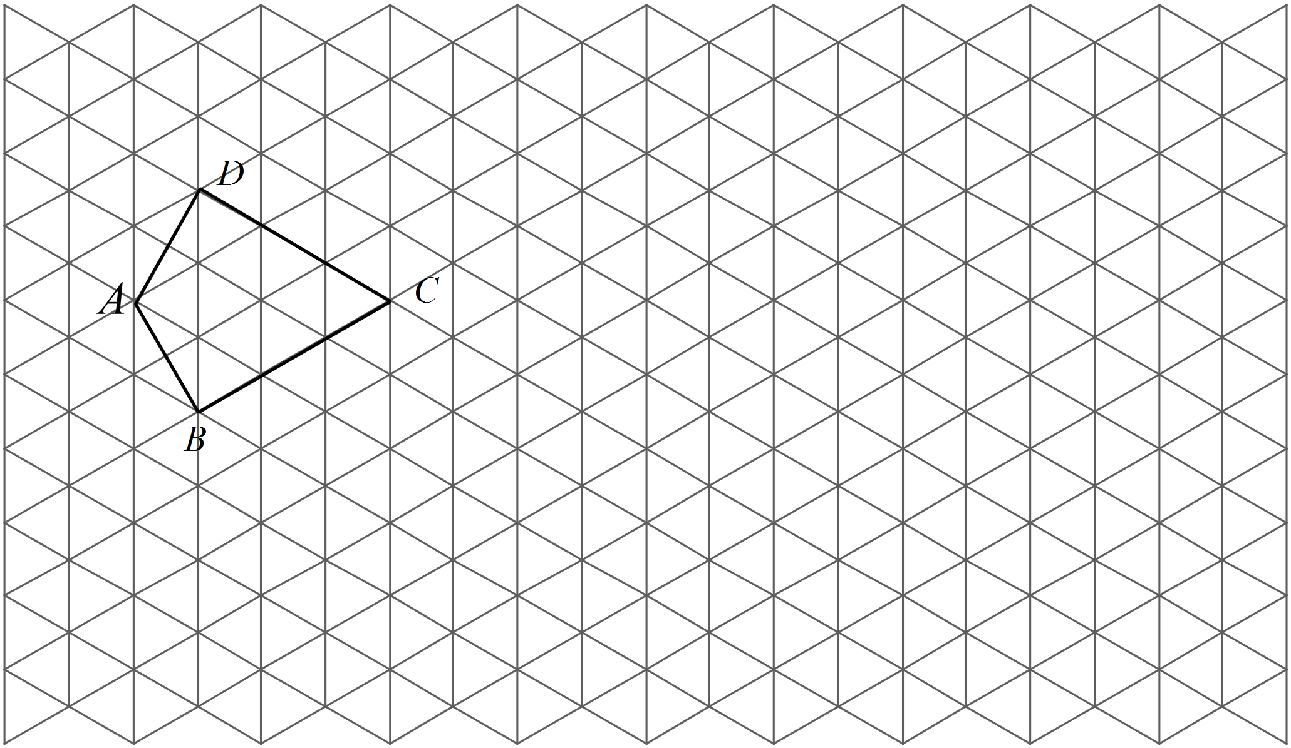 | 3
2. | 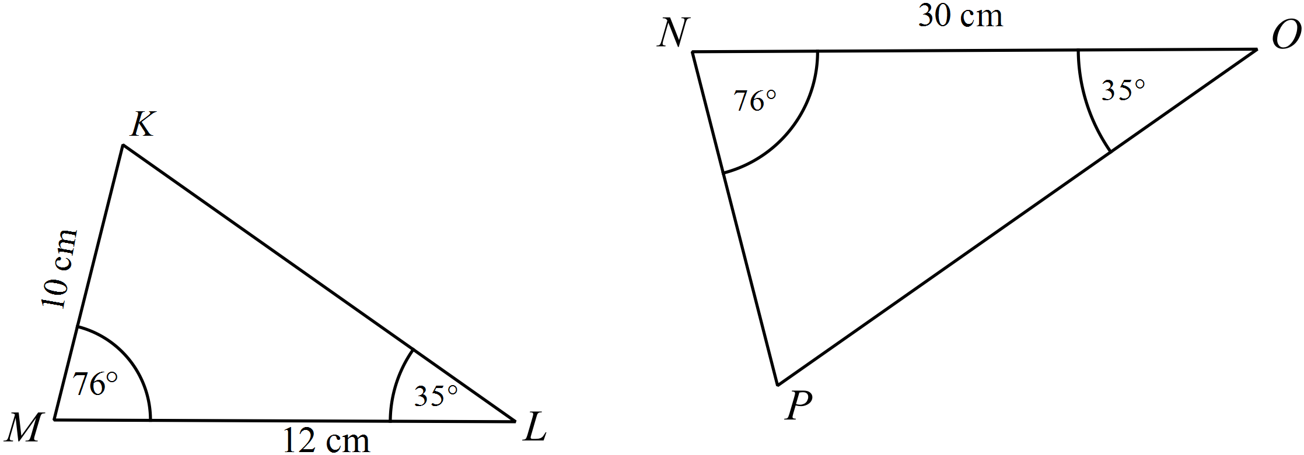  NOT TO  SCALE
 | a) Explain why 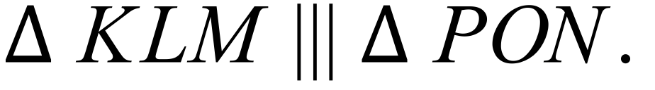  …………………………………………………………………………………………………………………………………………………  ………………………………………………………………………………………………………………………………………………… | 2
 | b) What is the ratio of the corresponding sides?  …………………………………………………………………………………………………………………………………………………  ………………………………………………………………………………………………………………………………………………… | 1
 | c) Find the length of NP.  ………………………………………………………………………………………………………………………………………………….  …………………………………………………………………………………………………………………………………………………  …………………………………………………………………………………………………………………………………………………. | 2
3. | (a) Use the grid below to assist with drawing an enlargement of ABCD form centre E with scale factor 3. (Show all construction lines and label the image appropriately.)  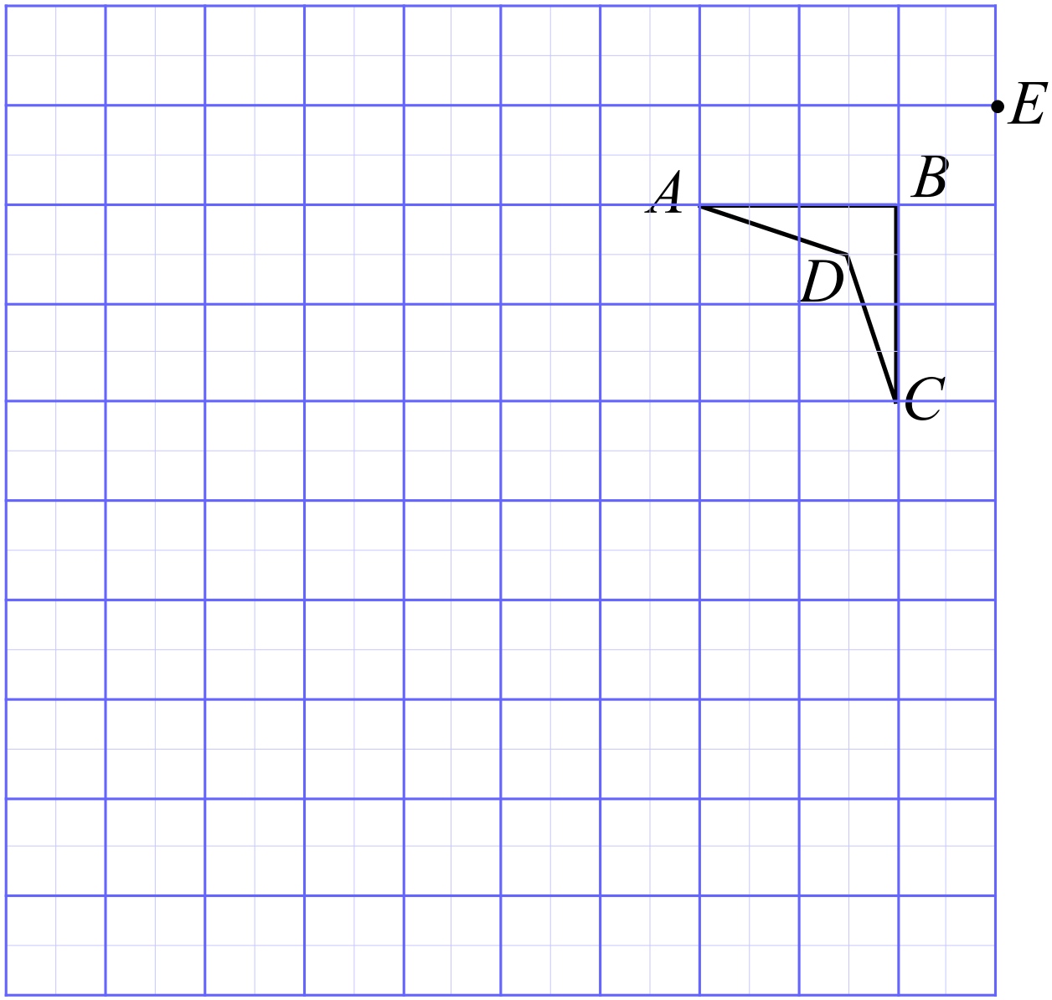 | 3
 | b) The perimeter of the original quadrilateral is 72 mm.  What is the perimeter of the enlarged quadrilateral?  ……………………………………………………………………………………………….  ………………………………………………………………………………………………. | 1
 | c) The area of the original quadrilateral is 1 cm².  What is the area of the enlarged quadrilateral?  ……………………………………………………………………………………………….  ………………………………………………………………………………………………. | 1
4. | (a) Given that AB || DE, prove that 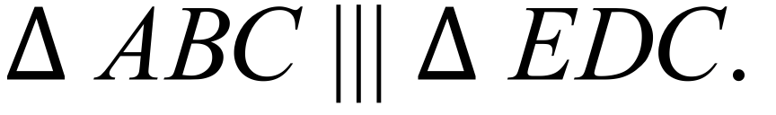  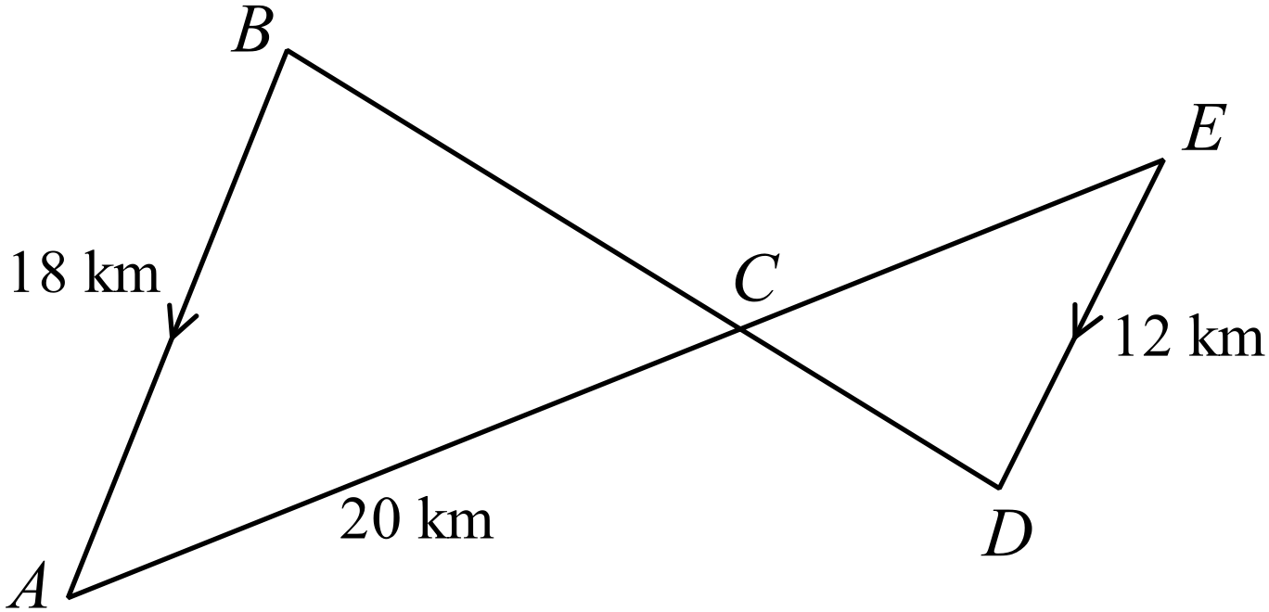  NOT TO  SCALE  ………………………………………………………………………………………………  ……………………………………………....………………………………………………  ……………………………………………....……………………………………………… | 2
 | (b) Find the length of CE.  ………………………………………………………………………………………………  ……………………………………………....………………………………………………  ……………………………………………....……………………………………………… | 2
5. | (a) is isosceles with  DE is drawn so that DB = EC = 5 cm.  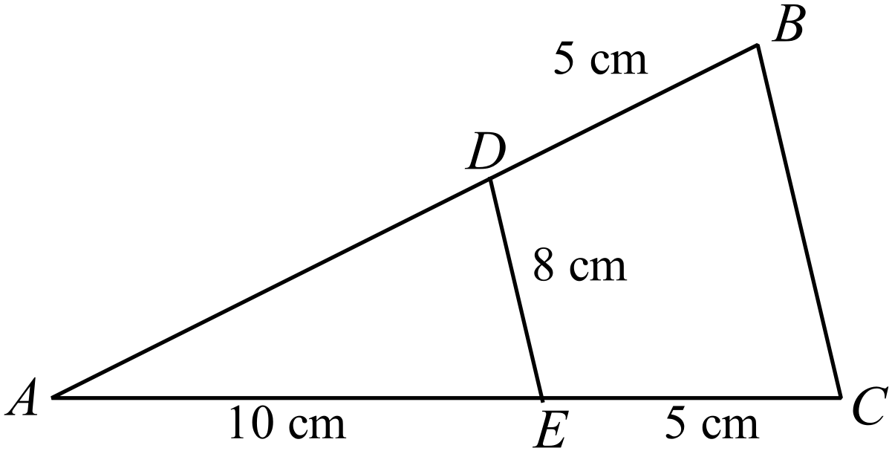 Prove that 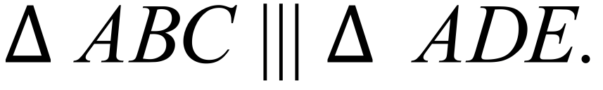  NOT TO  SCALE  ………………………………………………………………………………………………  ……………………………………………....………………………………………………  ……………………………………………....………………………………………………  ………………………………………………………………………………………………. | 2
 | (b) Find the length of BC.  ………………………………………………………………………………………………  ……………………………………………....………………………………………………  ……………………………………………....……………………………………………… | 2

School Name
Mathematics 2017
Multiple Choice Answer Sheet
Enlargement and Similarity
Name _____________________________________________
Completely fill the response oval representing the most correct answer.
1. A B C D
2. A B C D
3. A B C D
4. A B C D
5. A B C D
6. A B C D
7. A B C D
8. A B C D
9. A B C D
10. A B C D
11. A B C D
12. A B C D
13. A B C D
14. A B C D
15. A B C D

School Name
Mathematics Test 2017
Year 9 | Enlargement and Similarity | Non Calculator Section
ANSWERS

Question
Comparing corresponding sides
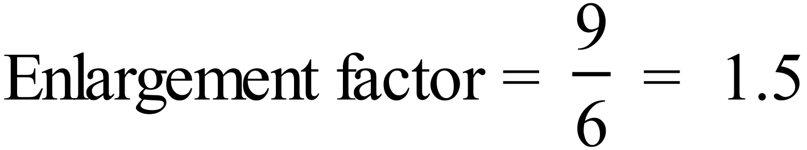
The image will have sides
There will still be a right angle between the two shorter sides.
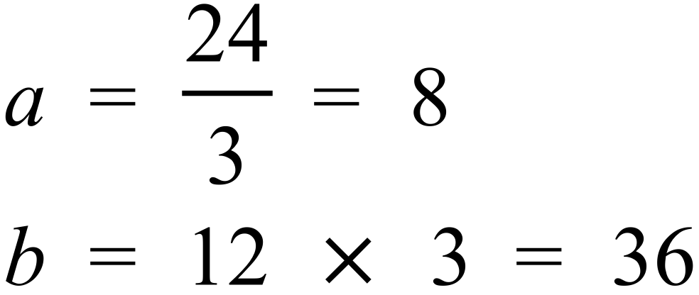
Each construction line has 6 divisions, the original triangle is at the 3rd division and the image is at the 6th, so the enlargement scale factor = 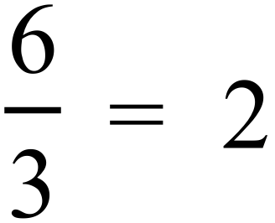
Measuring OL and OL’ gives 1.5 cm and 6 cm respectively.
scale factor = 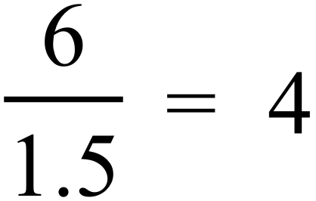
Can be done by comparing other distances,
AB corresponds to the shorter side.
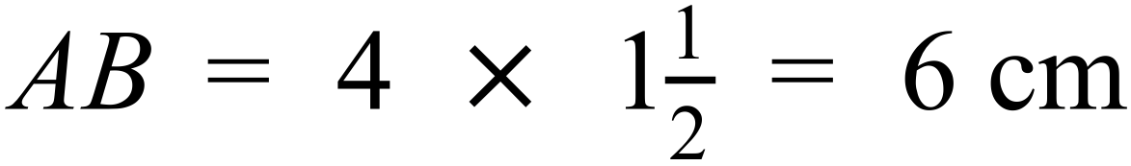
Measuring CE and CE’ gives 6 cm and 3 cm respectively.
scale factor = 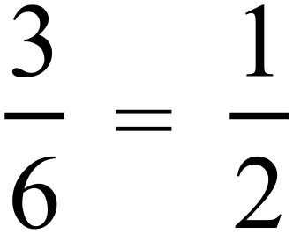
Any lengths which are multiples of 5 cm and 7 cm.
e.g Two sides of 7.5 cm and one of 10.5 cm.
Two sides of 10 cm and one of 14 cm.
Two sides of 15 cm and one of 21 cm.
Two sides of 2.5 cm and one of 3.5 cm.
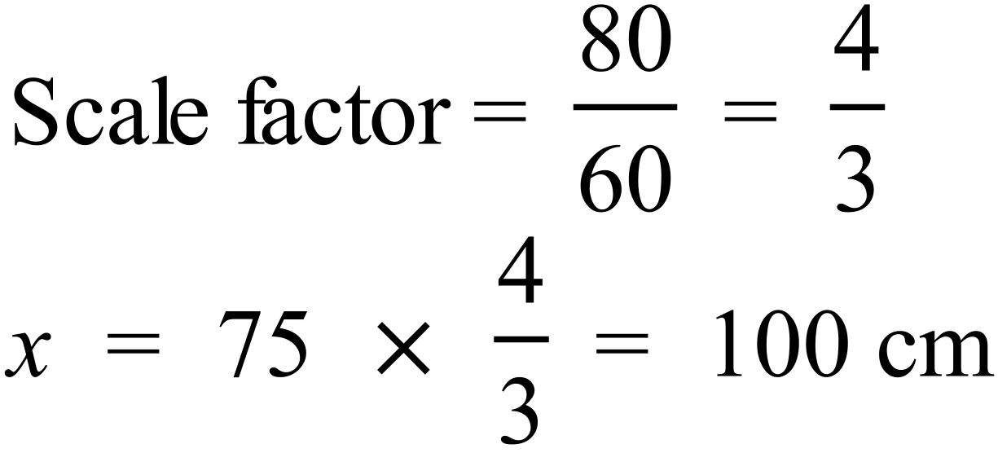
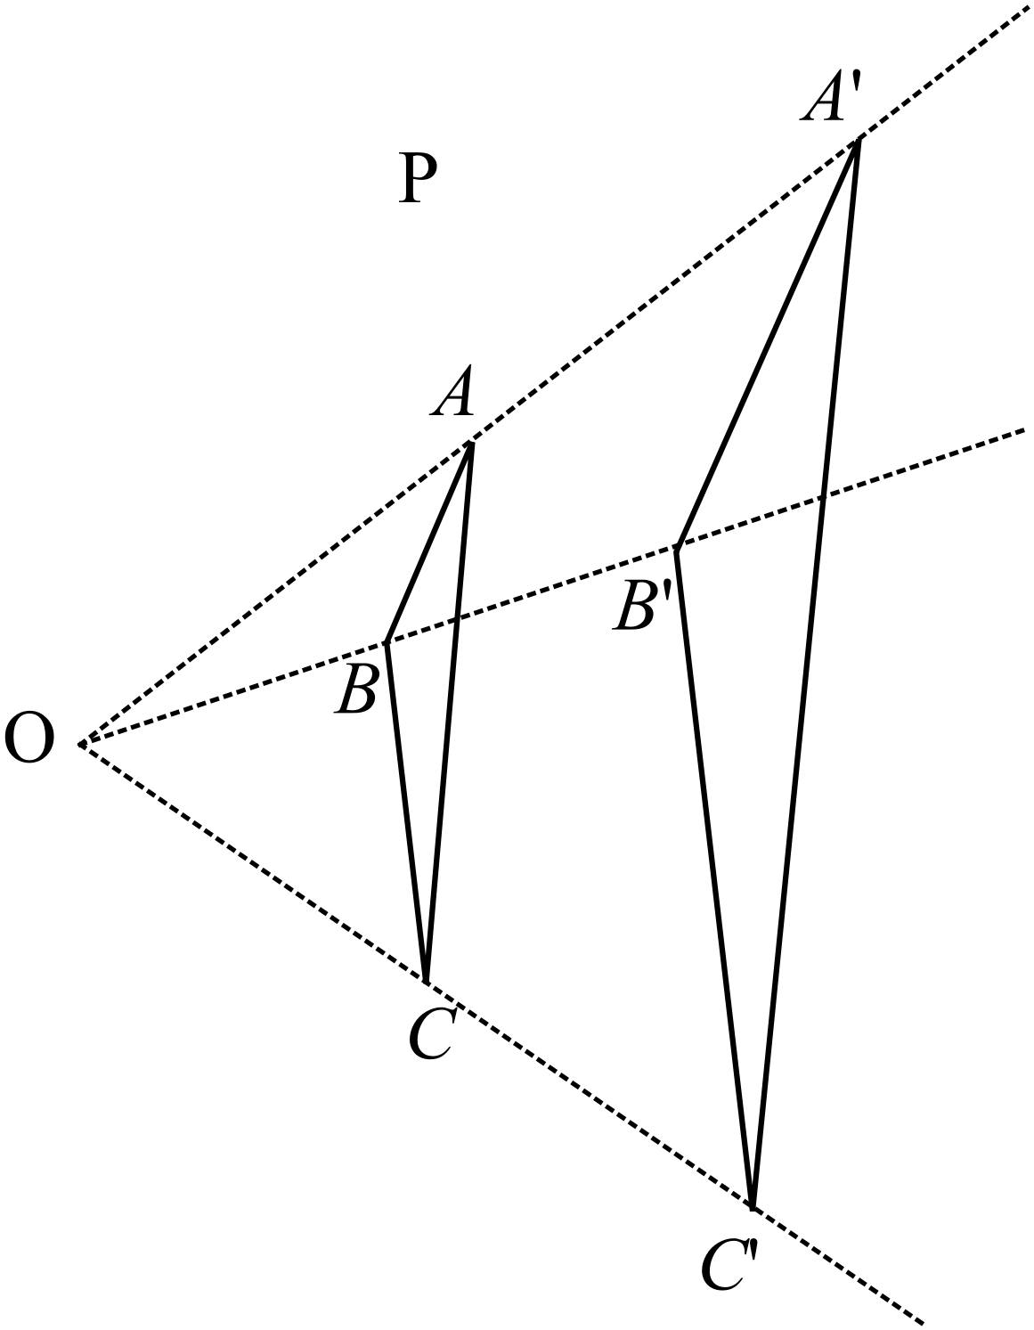

A’B’ = 4cm and B’C’ = 6cm
Scale factor = 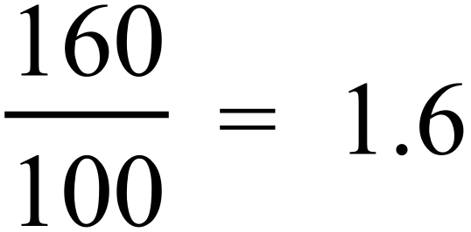

OR

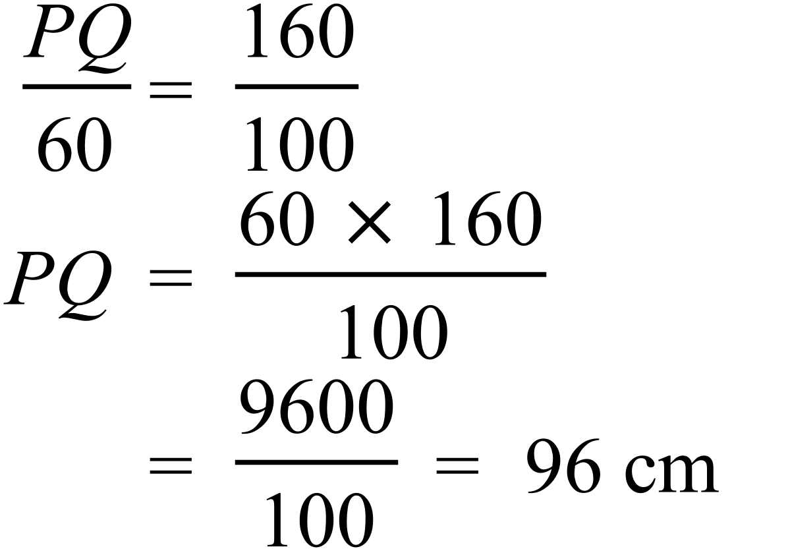
By measurement UW = 6 cm and U’W’ = 3 cm.
Scale factor =
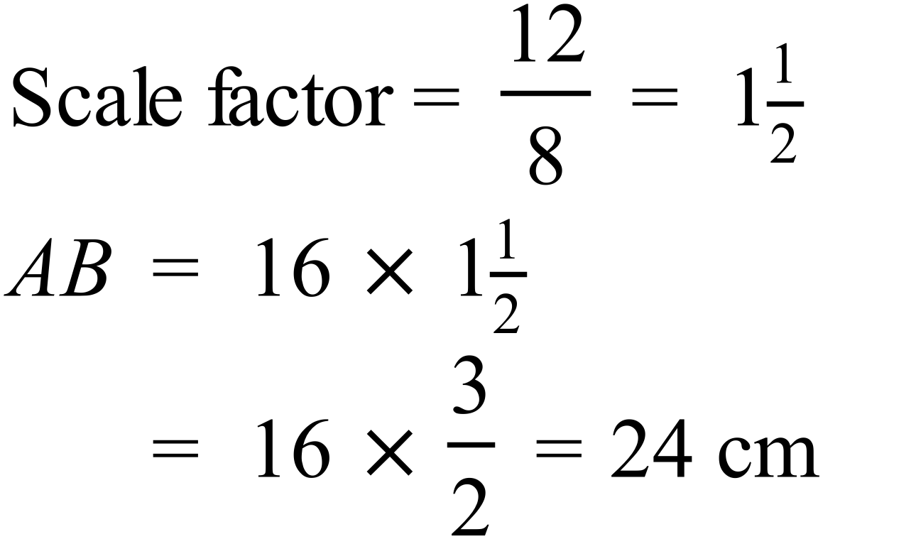
OR

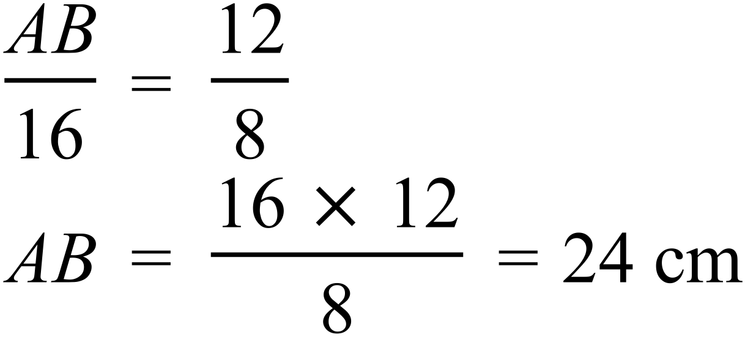
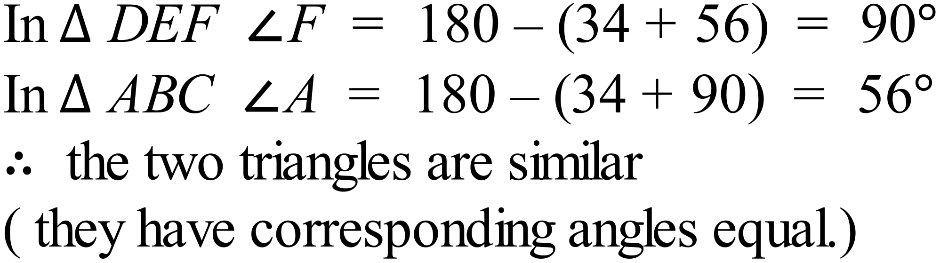
OR Equiangular due to angle sum of triangle.
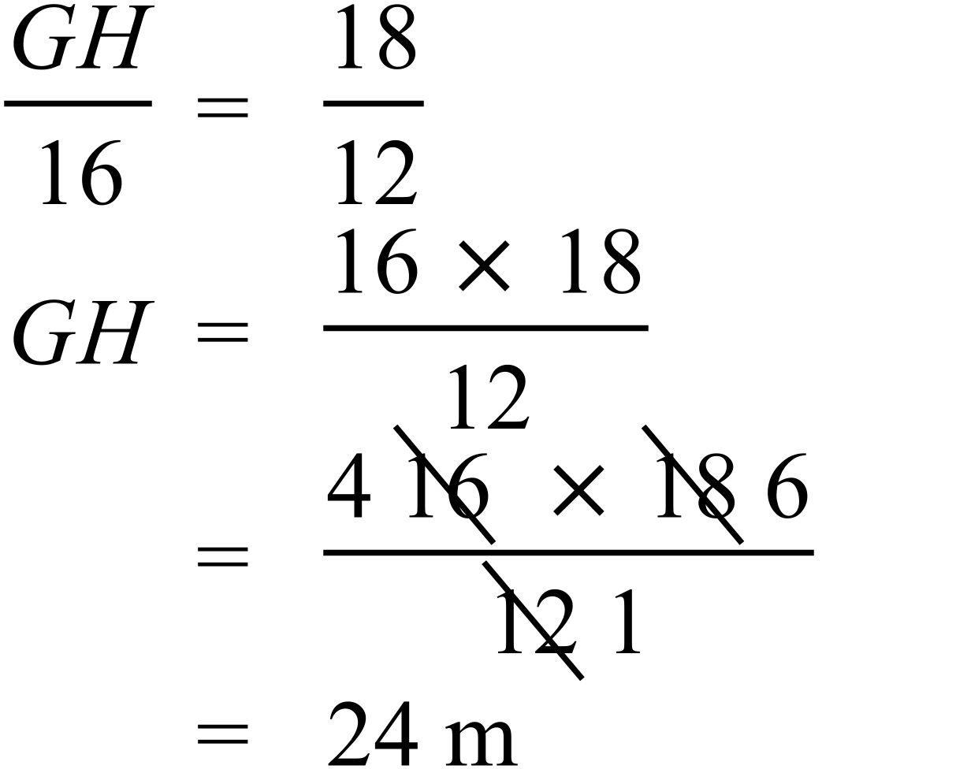
From the parallel lines and transversals, the equal angles are shown.
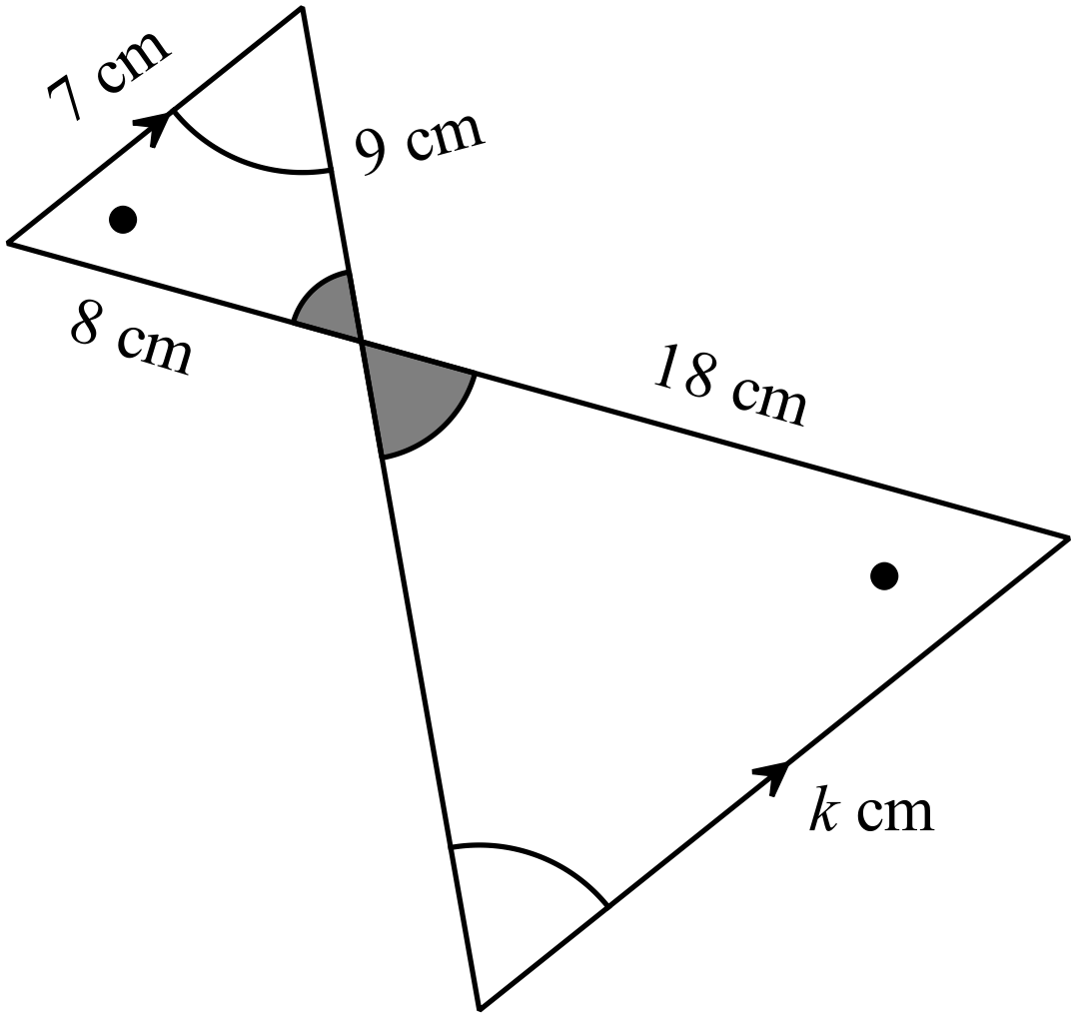

Matching corresponding sides,
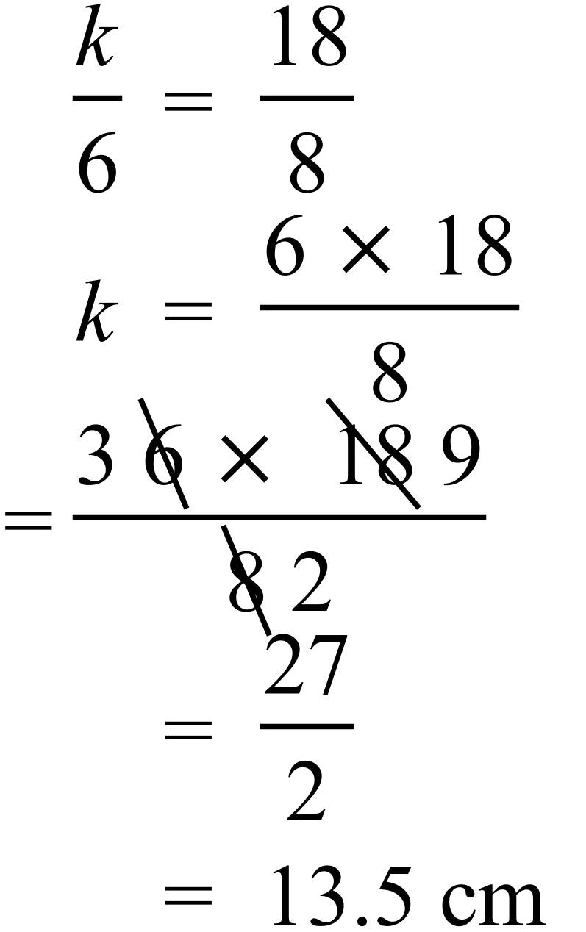

School Name
Mathematics Test 2017
Year 9 | Enlargement and Similarity | Calculator Allowed  Multiple Choice  Section

ANSWERS

 | Working | Answer
 | By measuring Rectangle D is 2.0 cm by 3.7 cm and Rectangle E is 6.0 cm by 11.1 cm.  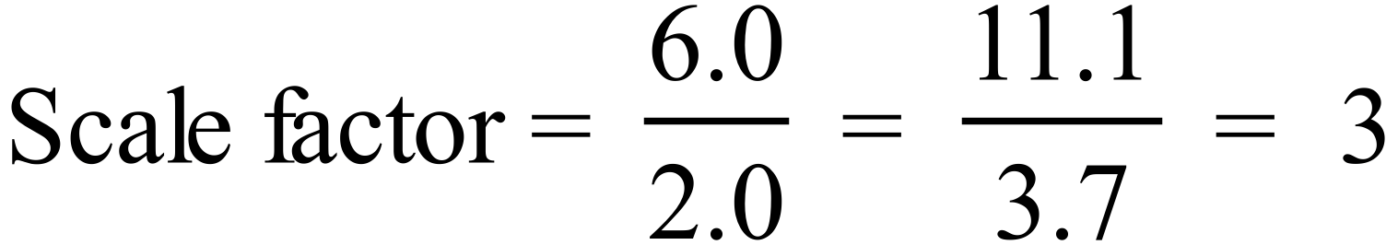  Different measurements may be possible depending on printing, but answer is the same | D
 | 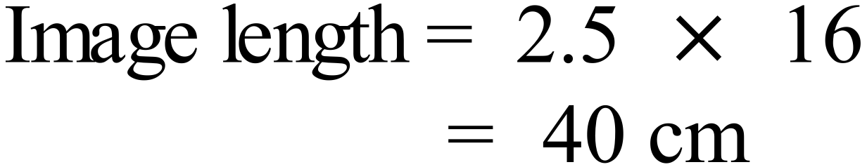 | D
 | 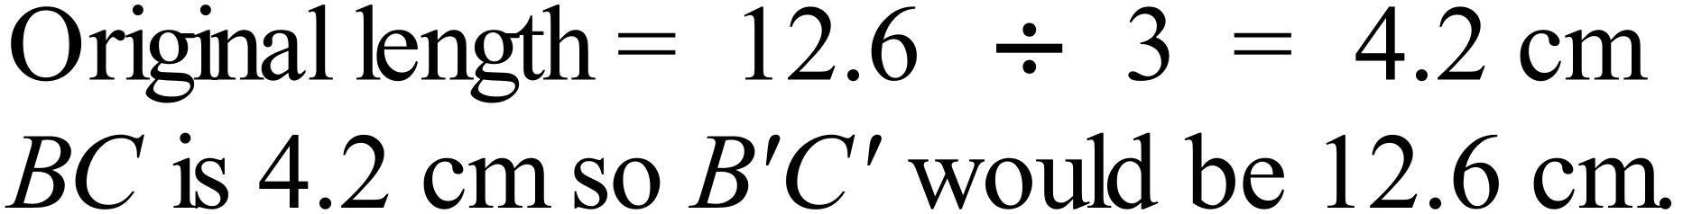 | B
 | Scale factor = 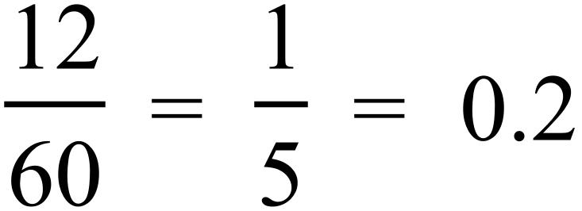  Height of model = 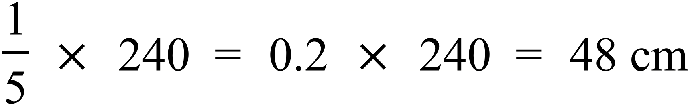 | A
 | The first two are correct as they give the ratio of corresponding sides (which are in the same ratio).  The last is correct as it equates two corresponding angles (which are equal).  Option C pairs two angles which are not corresponding, so are not equal. | C
 | All of the options have a measurement which is twice that in 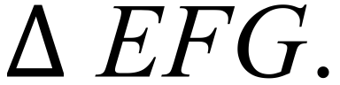 If  was enlarged with factor 2, the measurements would be 7 cm. 9 cm and 10 cm.  So option A is similar to | A
 | 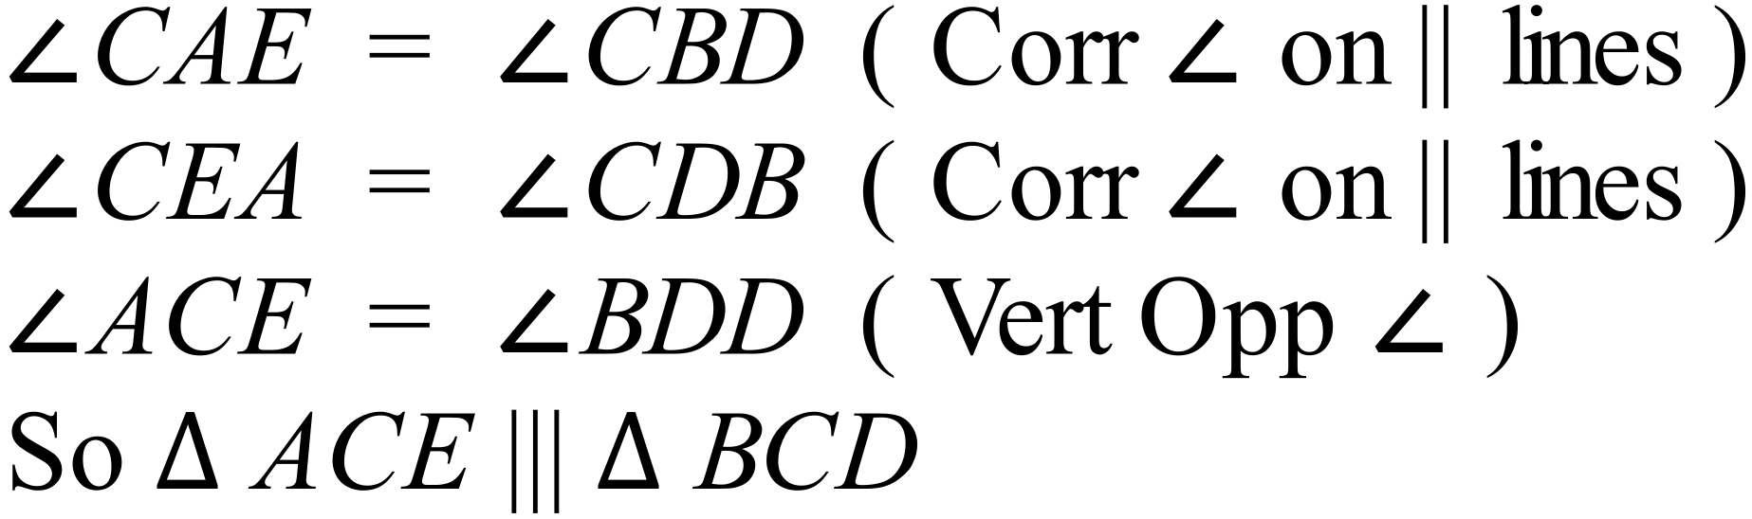 | B
 | For all of the regular figures, because all angles are equal and all sides are equal, any two figure will have corresponding angles equal and corresponding sides in the same ratio.  This does not apply for an isosceles triangle as all sides are not equal and two isosceles triangles can have angles which are different. | C
 | 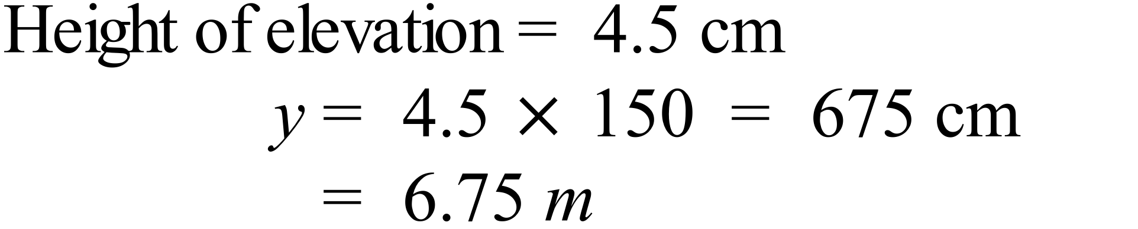 | B
 | 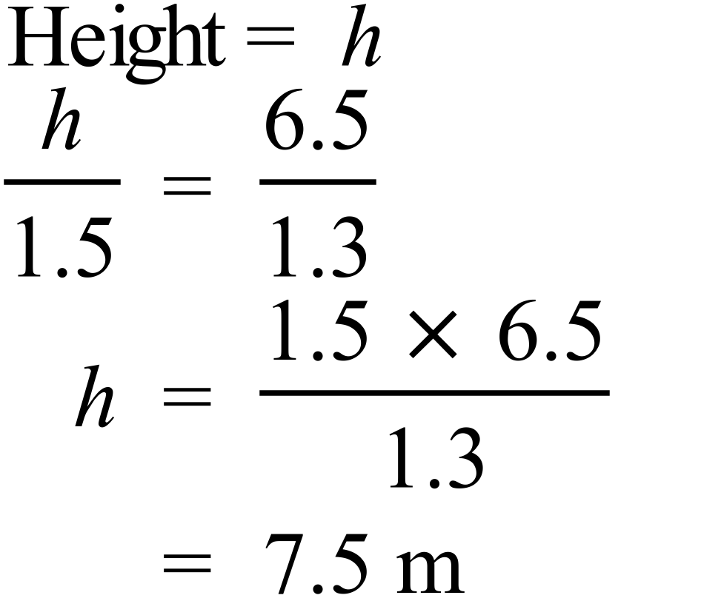 | C
 | 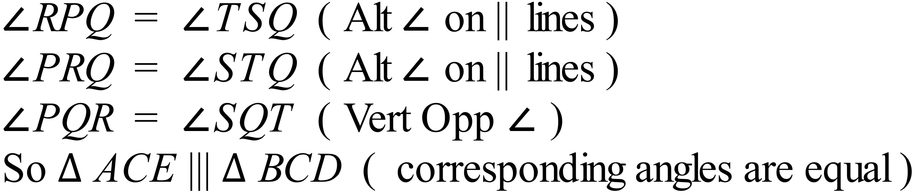 | A
 | 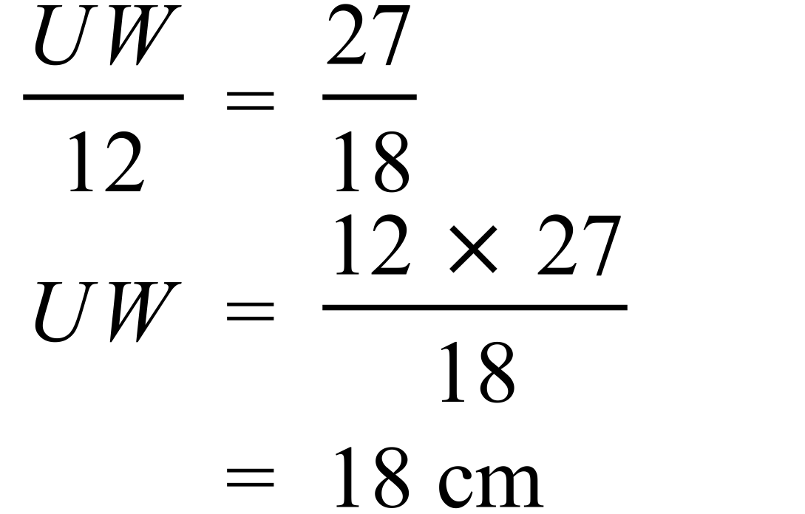 | B
 | Matching corresponding sides:  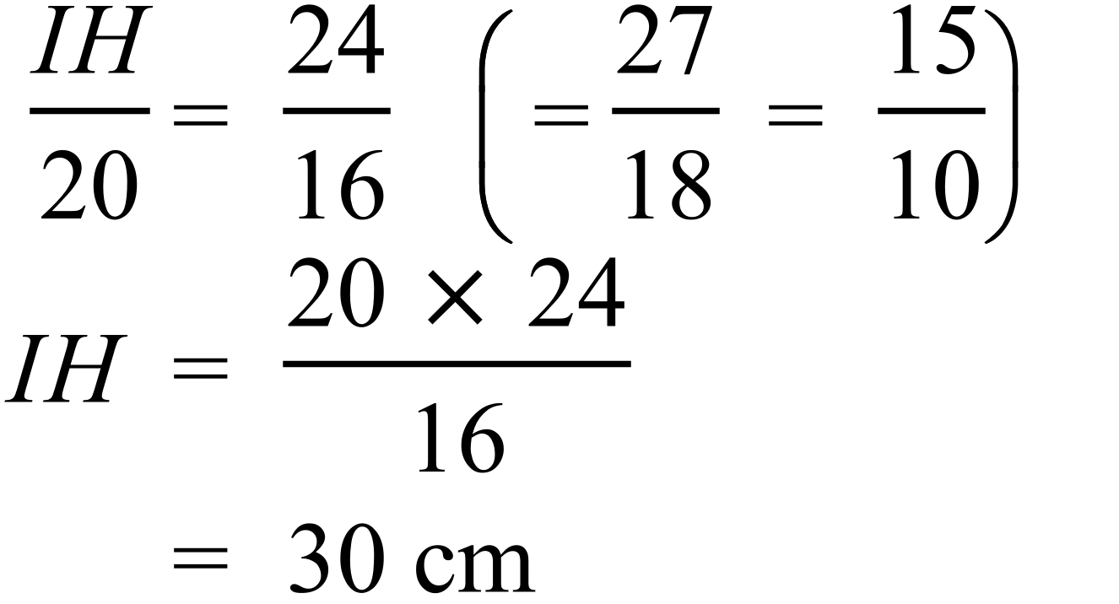 | D
 | 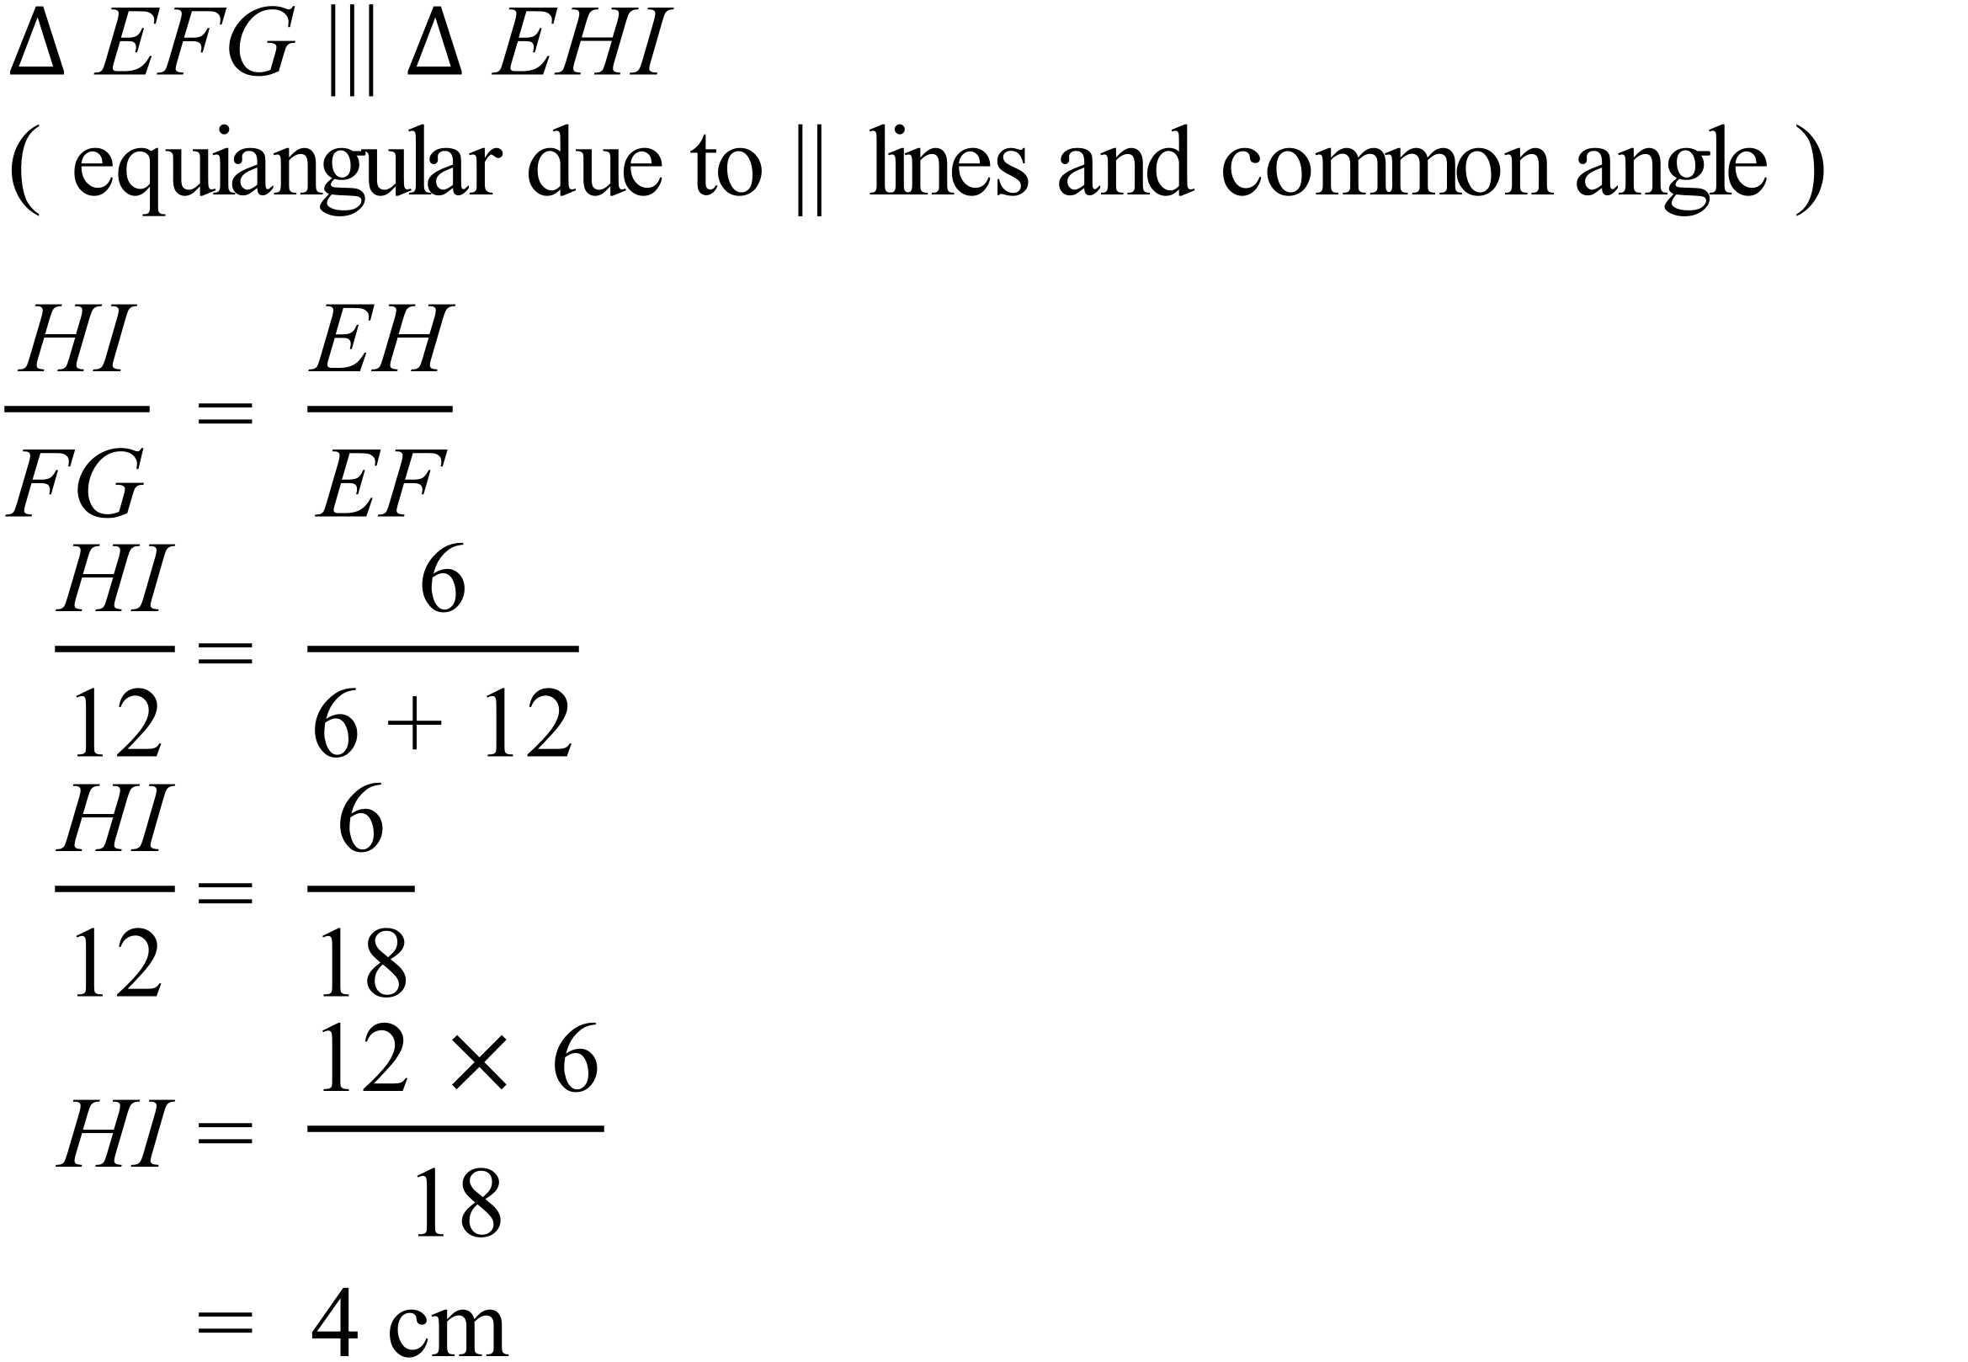 | A
 | 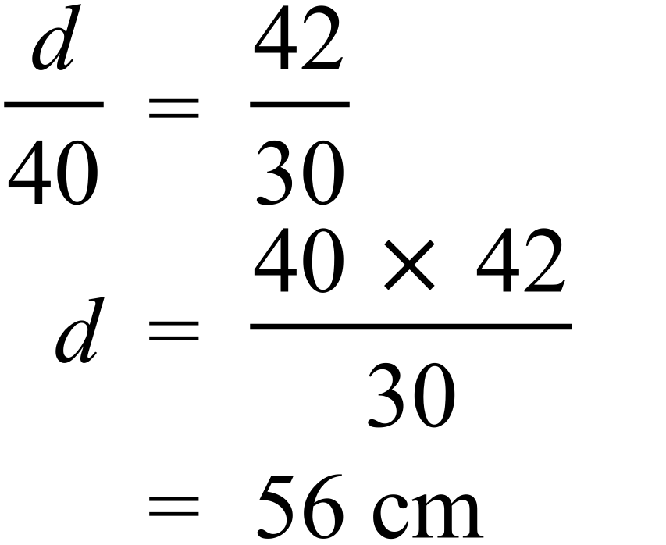 | C

School Name
Mathematics 2017
Multiple Choice Answer Sheet
Enlargement and Similarity
Name _____________________________________________
Completely fill the response oval representing the most correct answer.
1. A B C D
2. A B C D
3. A B C D
4. A B C D
5. A B C D
6. A B C D
7. A B C D
8. A B C D
9. A B C D
10. A B C D
11. A B C D
12. A B C D
13. A B C D
14. A B C D
15. A B C D

School Name
Mathematics Test 2017
Year 9 | Enlargement and Similarity | Calculator Allowed  Longer Answer  Section
ANSWERS
Question | Answer | Marks
1. | 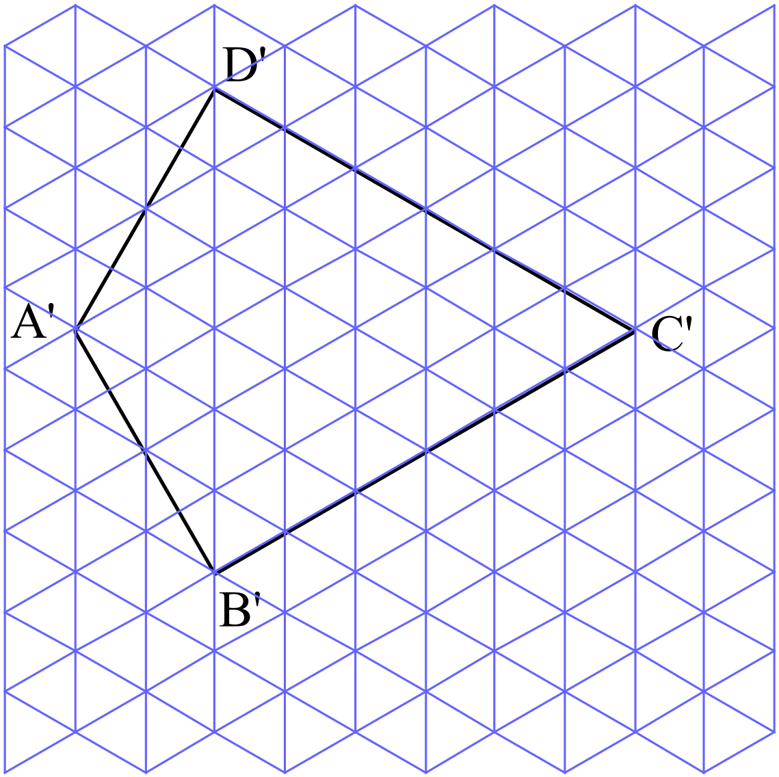 | As no centre is specified, position can be anywhere on the grid.  2 marks for correct shape and size.  1 mark if the size is generally correct, with a single vertex misplaced or overall size is incorrect but shape is correct.
2. | (a) 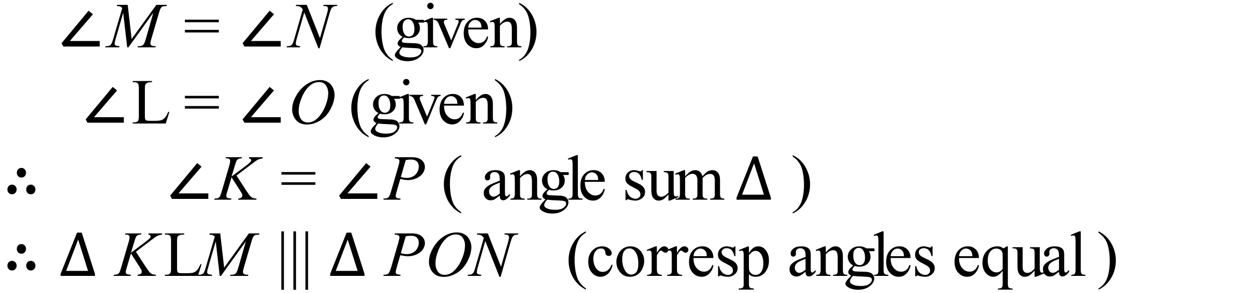 | 2 marks for explanation that lists at least two equal pairs of angles and includes mention of corresponding angles being equal as a reason for similarity.  1 mark for answer which mentions or lists some equal angles
 | (b) 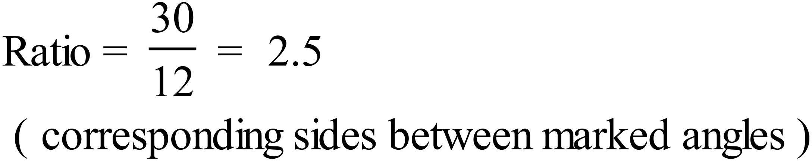 | 1 for correct answer
 | (c) 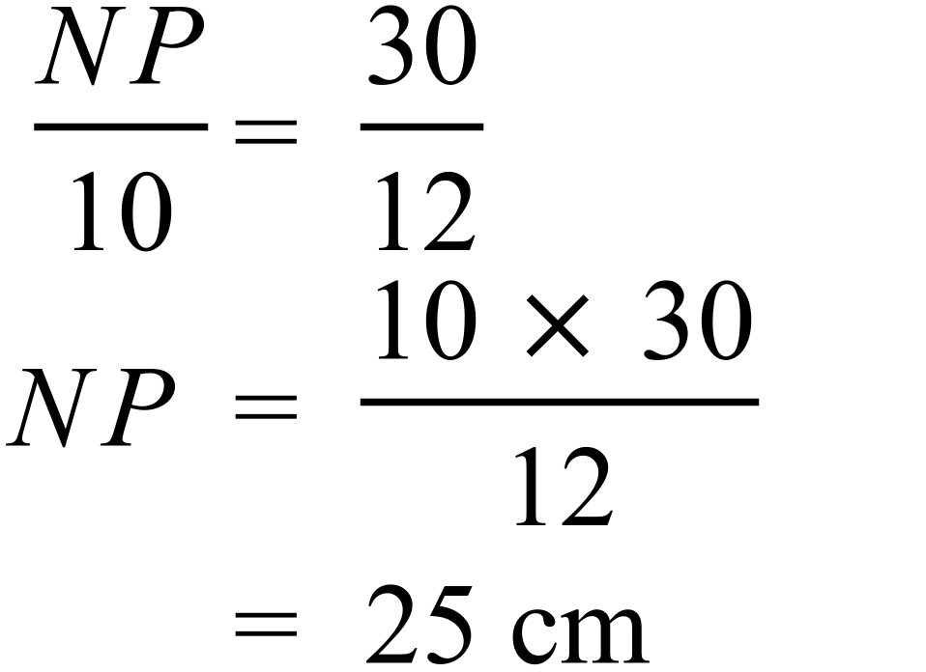 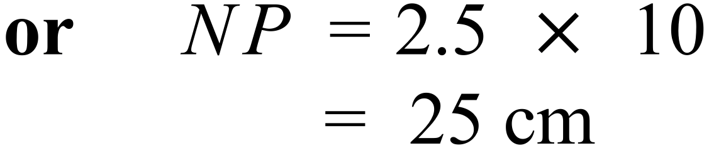 | 2 marks for correct answer.  1 mark for working with an error in calculation or algebra.
3. | 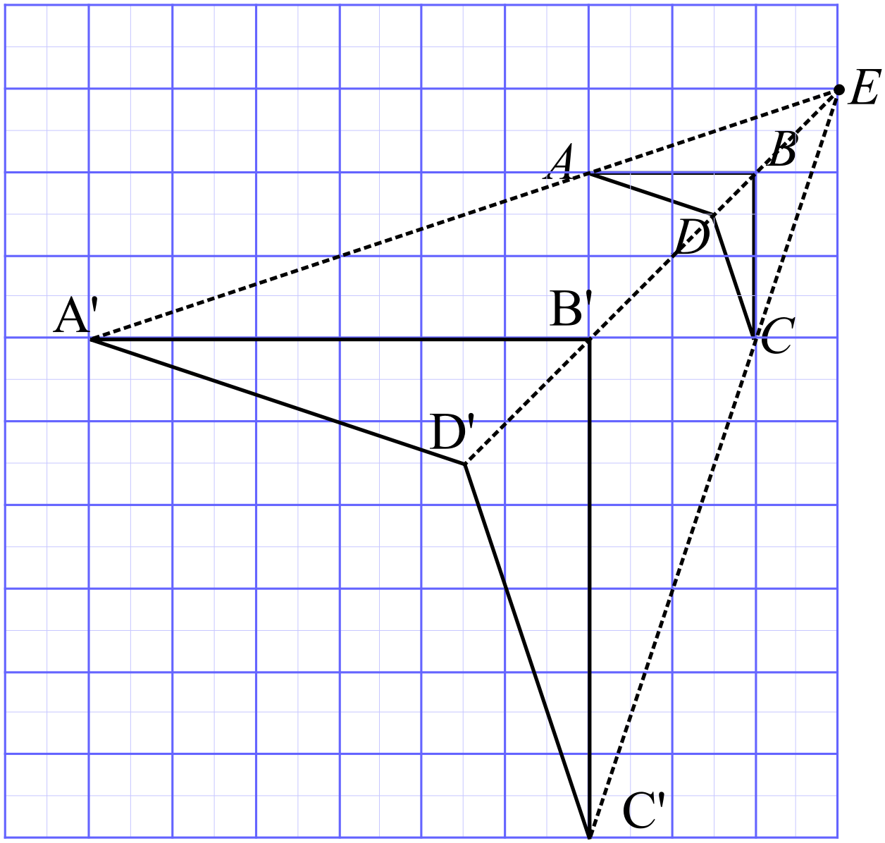(a) | 3 marks for all points located correctly and labelled correctly with clear construction lines.  2 marks for or most points located correctly or if not labelled correctly with clear construction lines.  1 mark for an attempt which shows some knowledge of enlargement.
 | (b) | 1 mark for correct answer
 | (c) | 1 mark for correct answer
4. | (a)  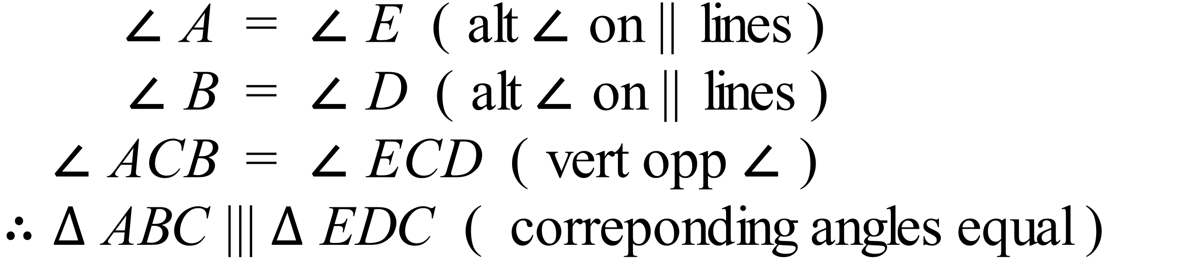 | 2 marks for explanation that lists at least two equal pairs of angles and includes mention of corresponding angles being equal as a reason for similarity.  1 mark for answer which mentions or lists some equal angles
 | (b)  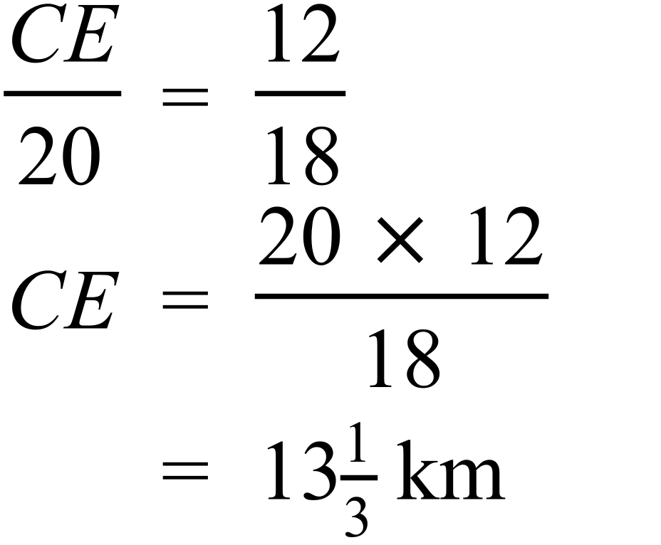 | 2 marks for correct answer.  1 mark for working with an error in calculation or algebra.
5. | (a) 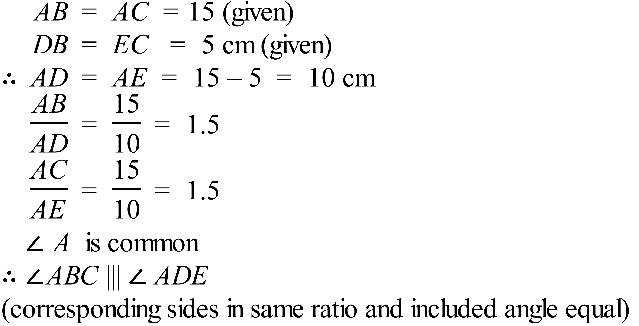 | 2 marks for explanation that lists at least two equal pairs of angles and includes mention of corresponding angles being equal as a reason for similarity.  1 mark for answer which mentions or lists some equal angles
 | (b) 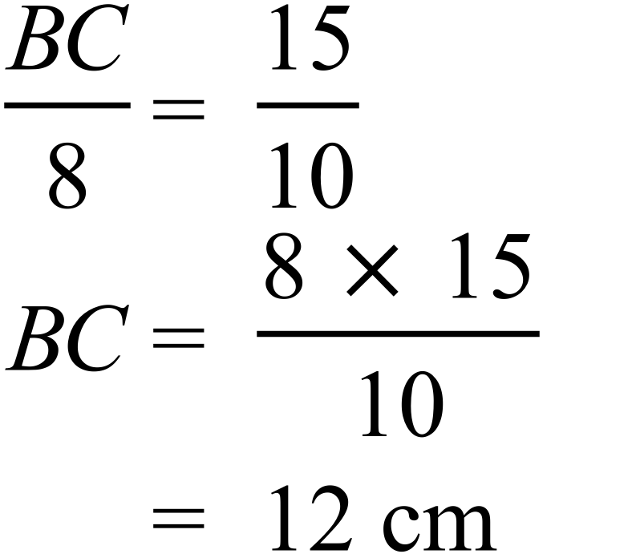 | 2 marks for correct answer.  1 mark for working with an error in calculation or algebra.

